**Spring Microservice**

[**https://microservices.io/patterns/index.html**](https://microservices.io/patterns/index.html)

[**https://www.enterpriseintegrationpatterns.com/**](https://www.enterpriseintegrationpatterns.com/)

**-patterns of java micro services**

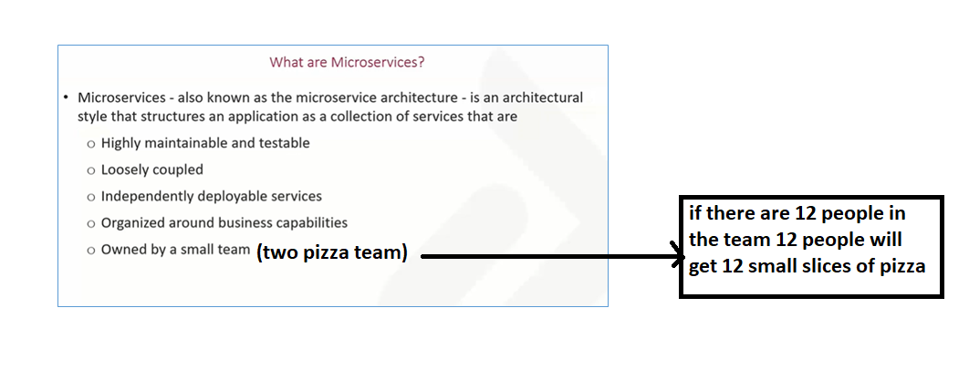

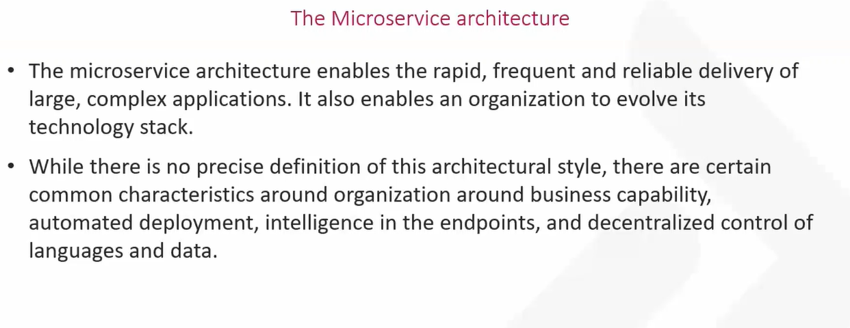

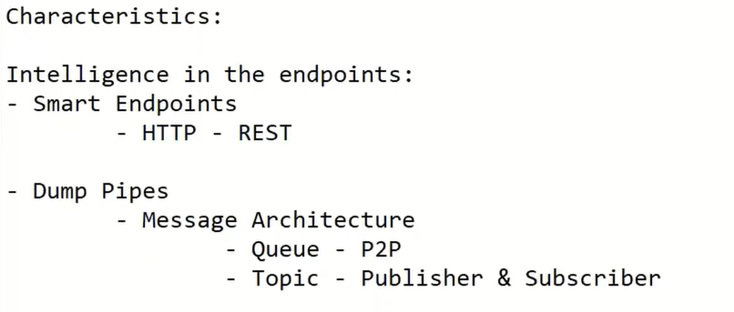

[**https://martinfowler.com/articles/microservices.html**](https://martinfowler.com/articles/microservices.html) **-** micro services by martin fowler

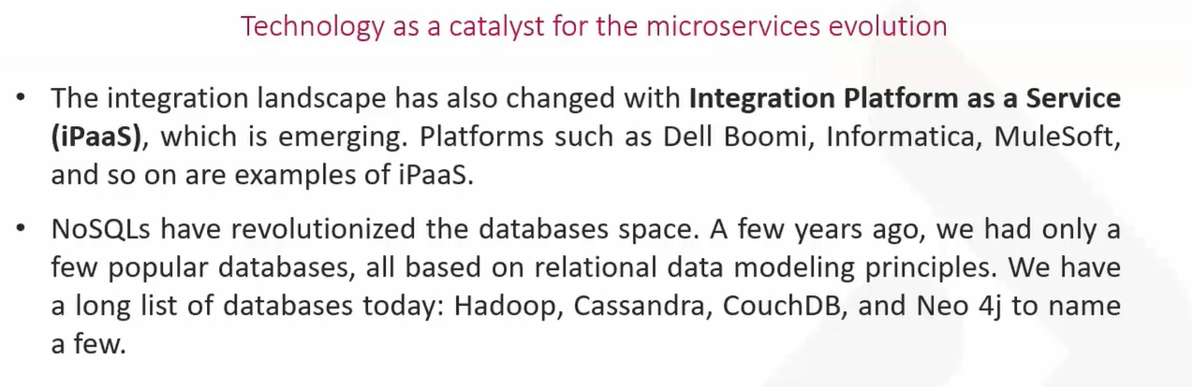

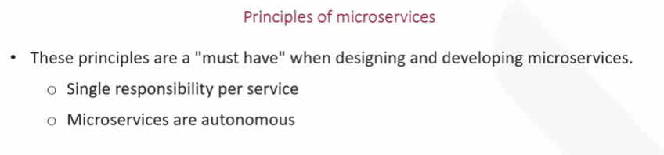

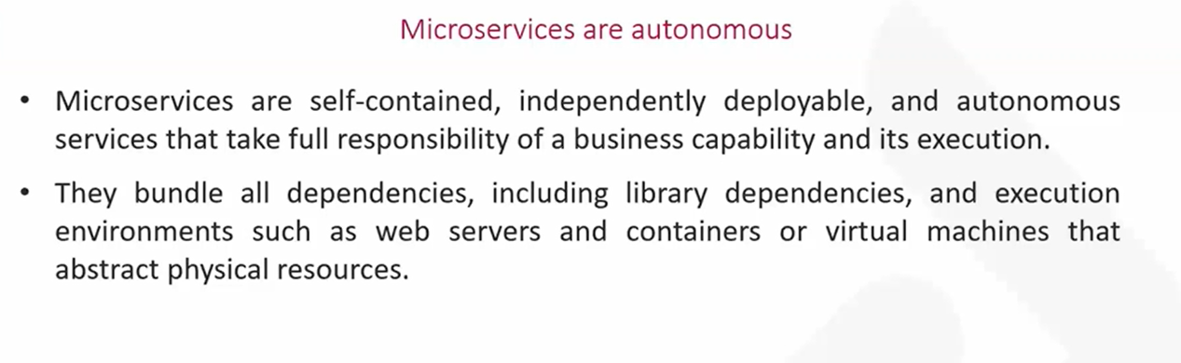

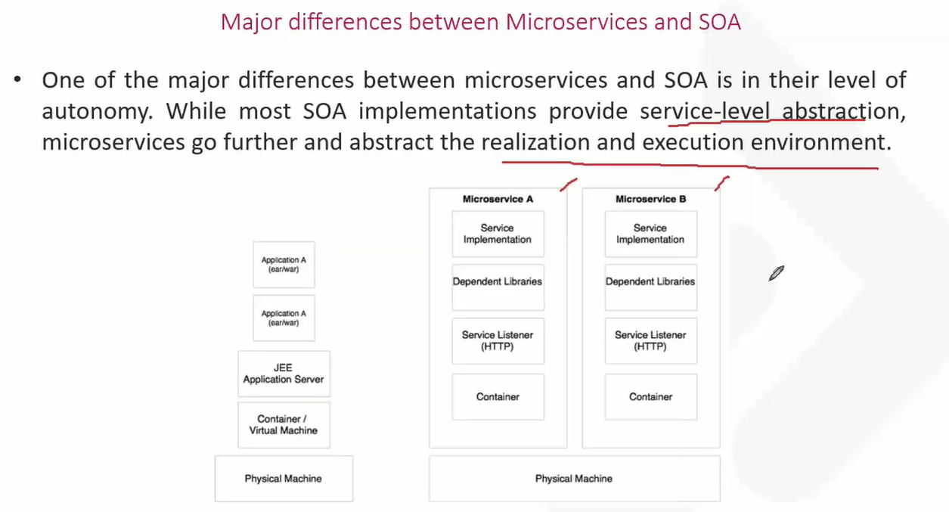

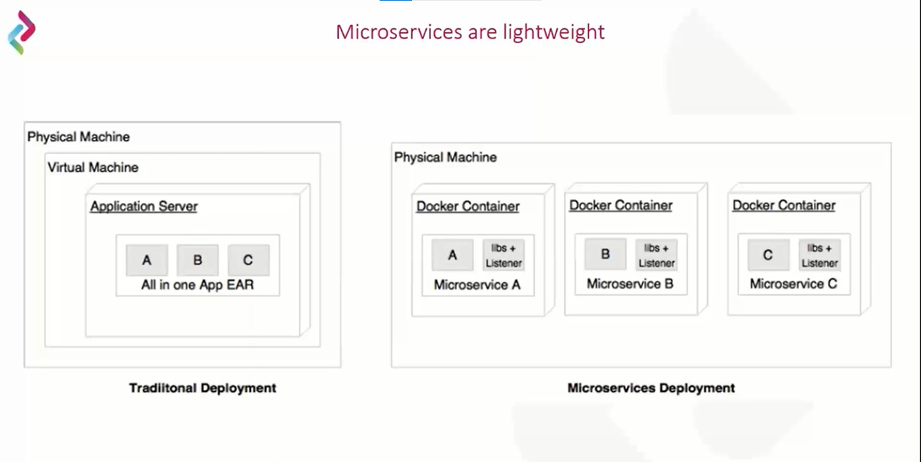

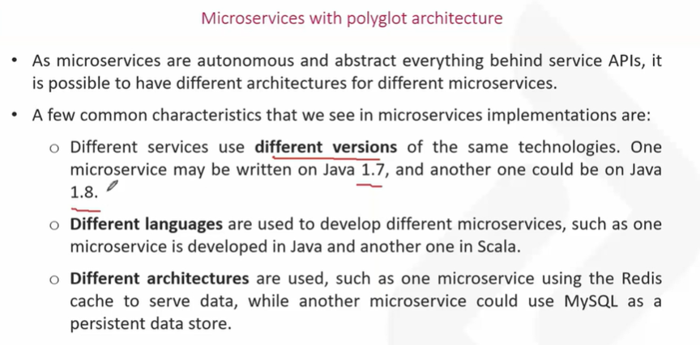

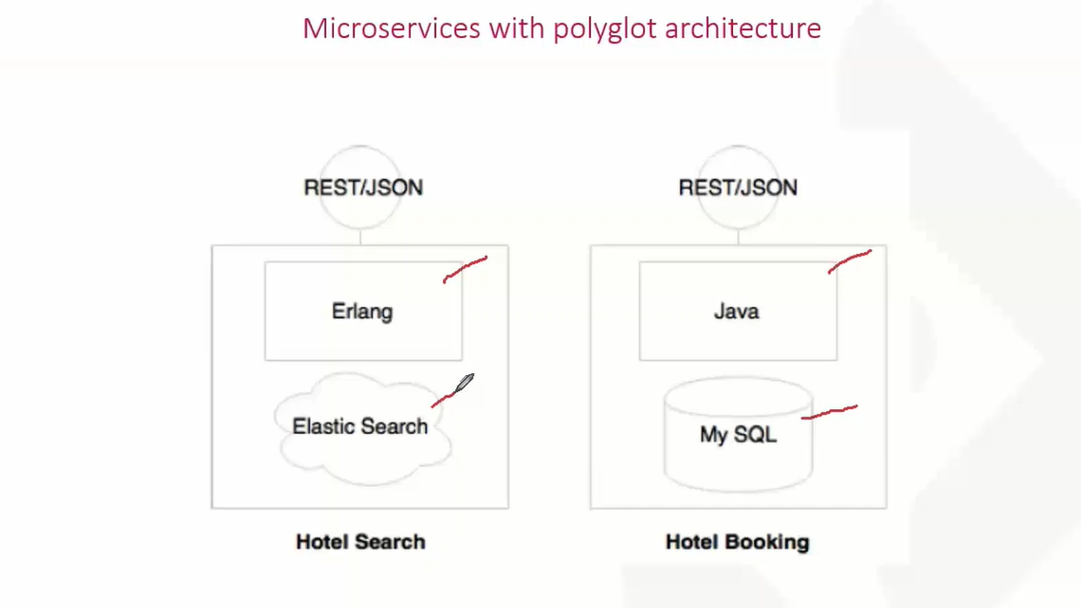

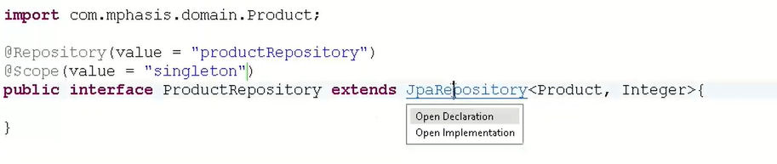



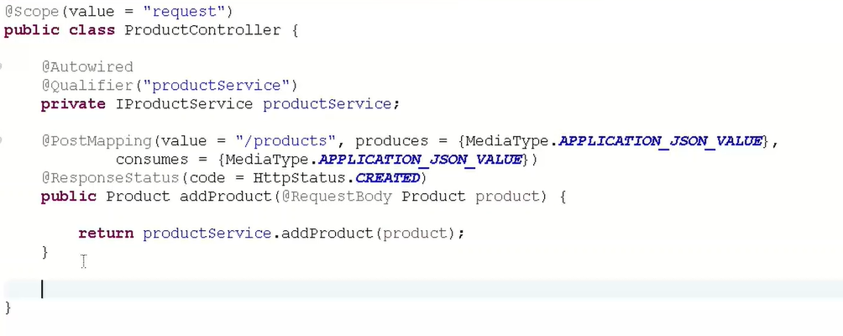

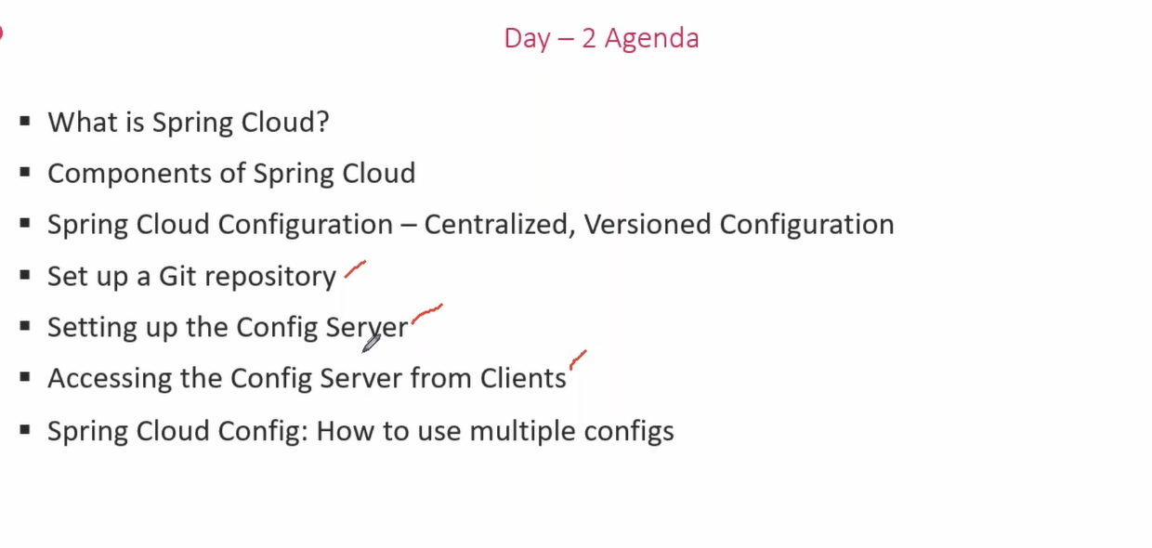

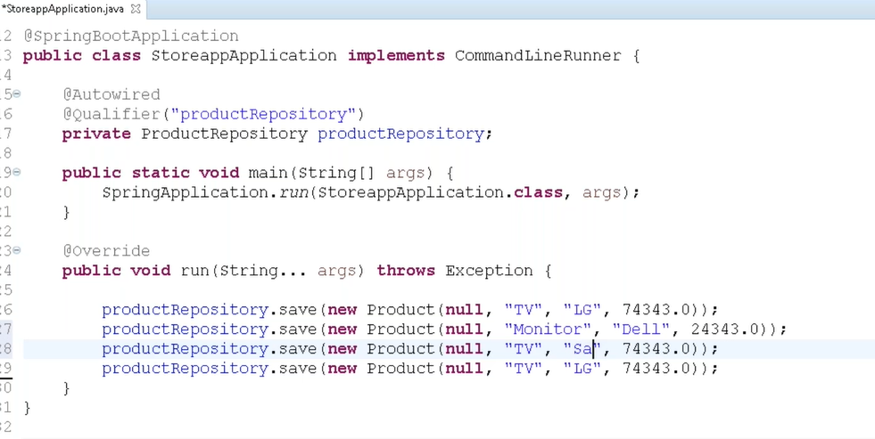

**Adding dummy data when a spring application is started**

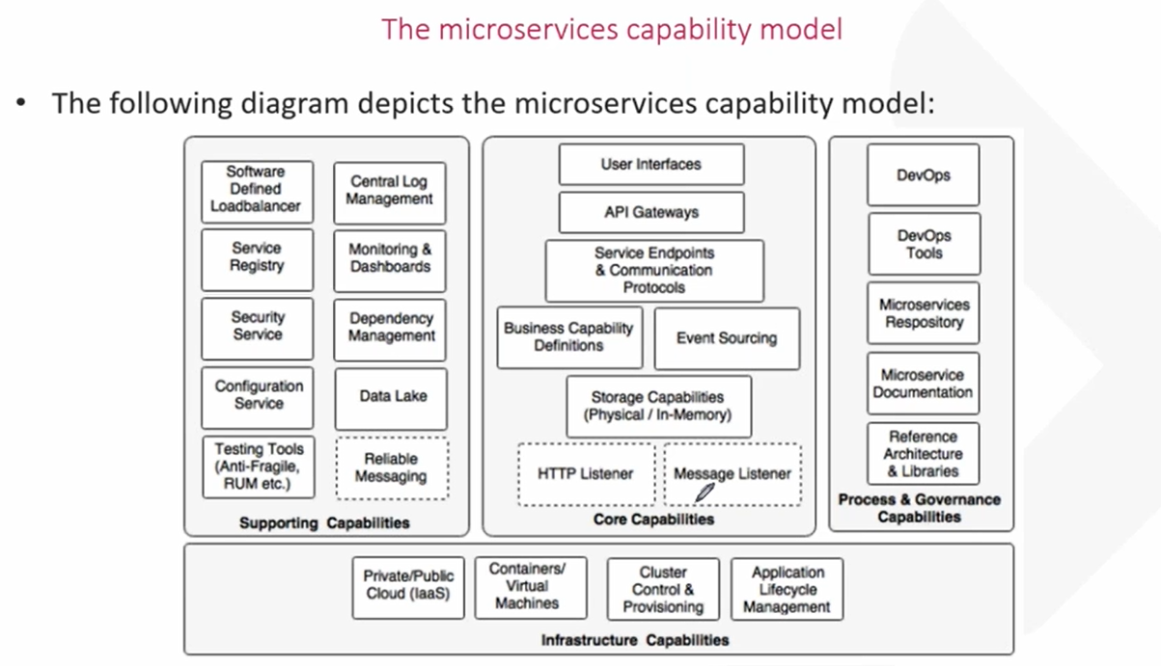

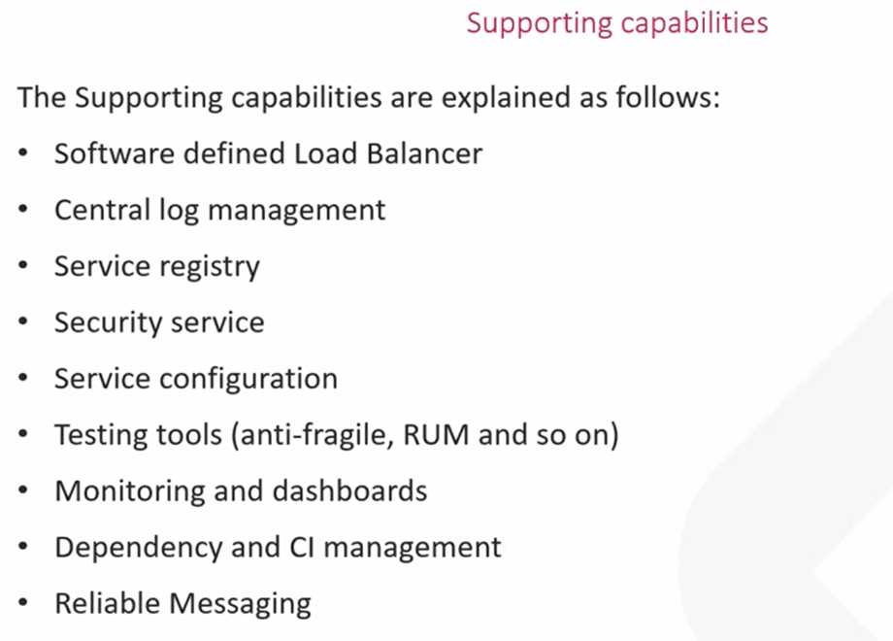

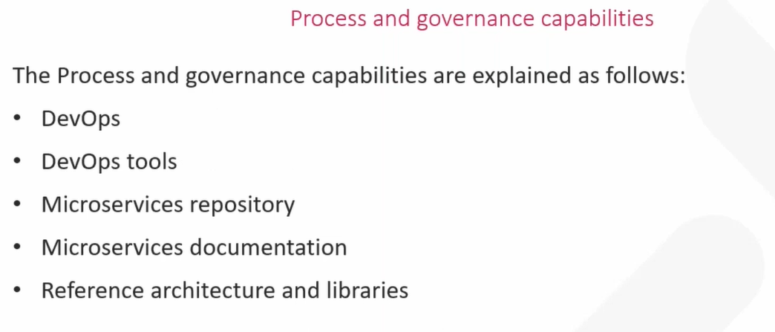

**Spring cloud**

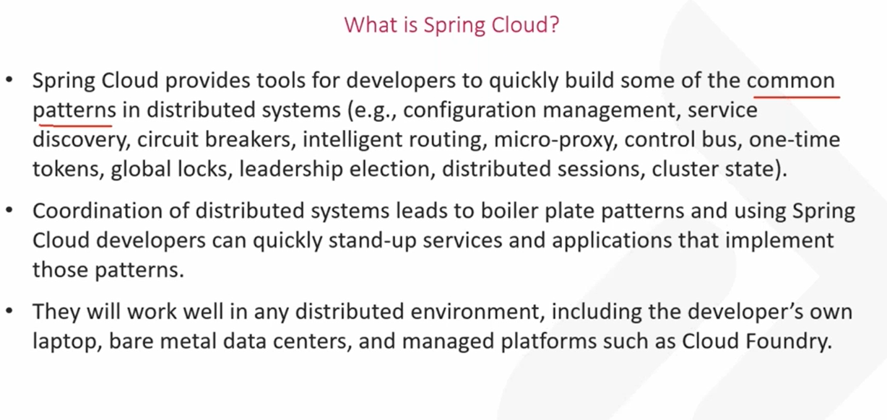

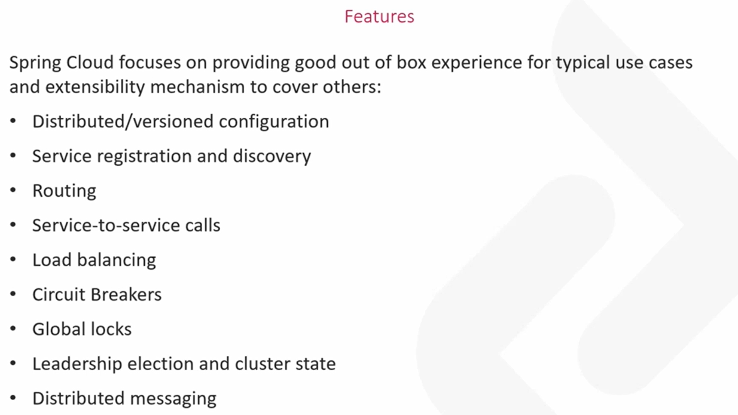

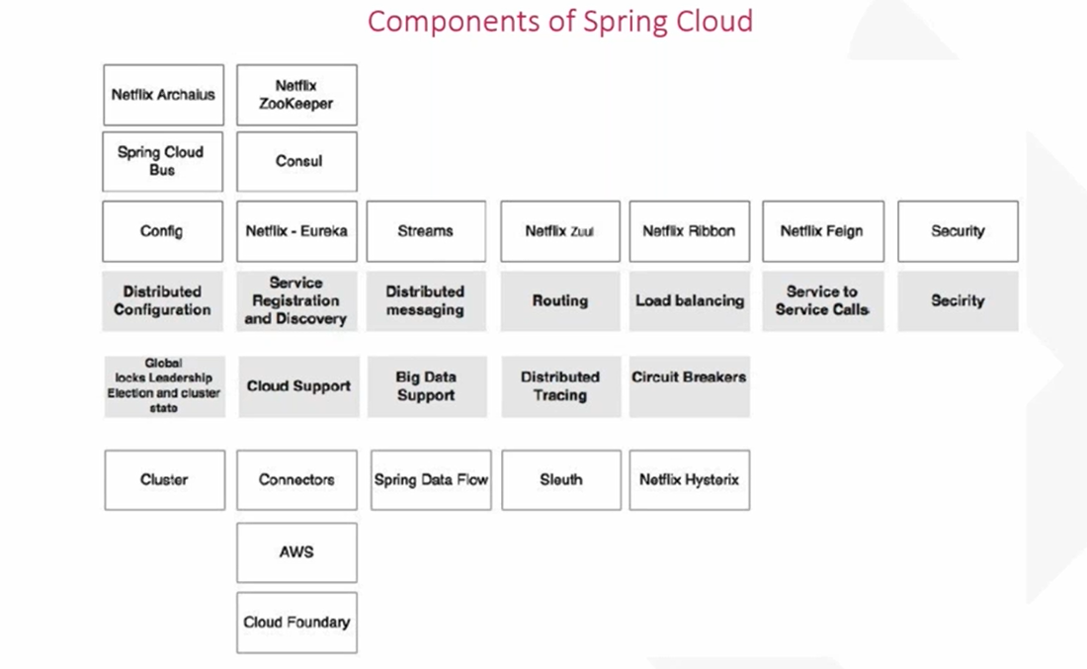

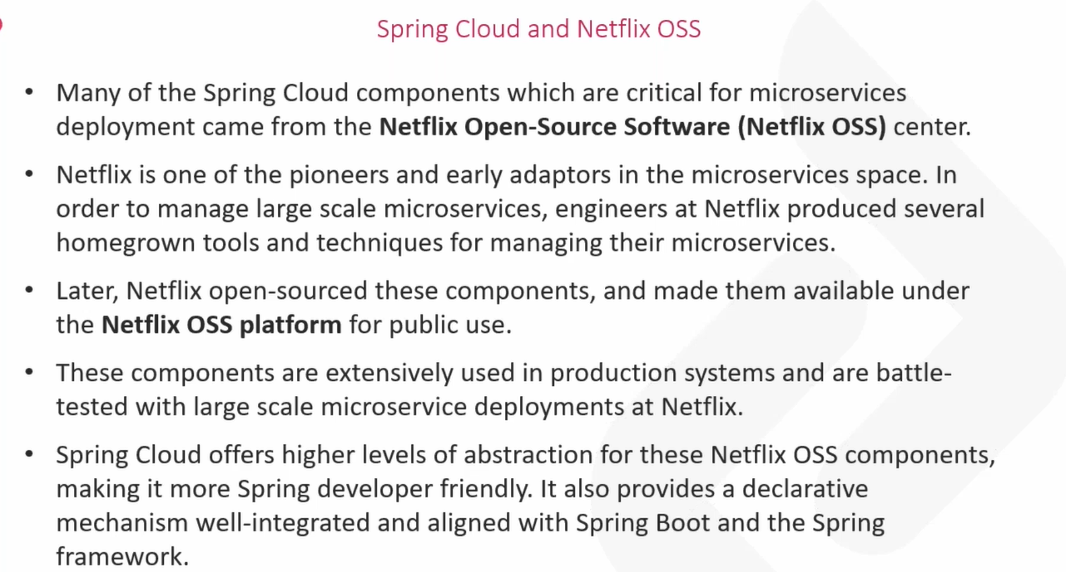

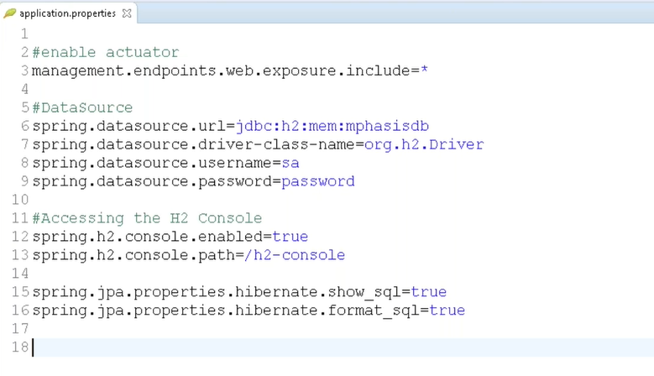

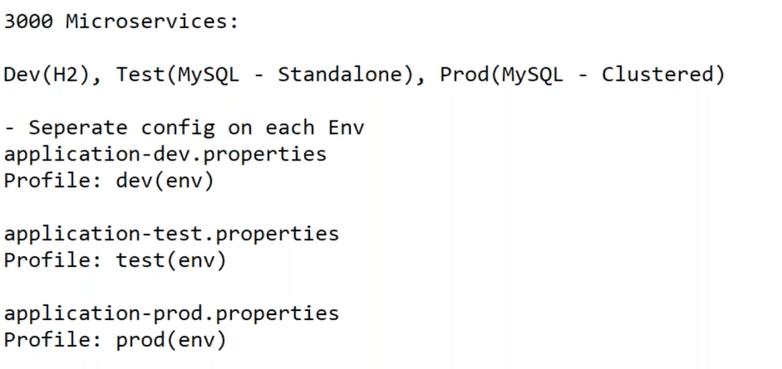

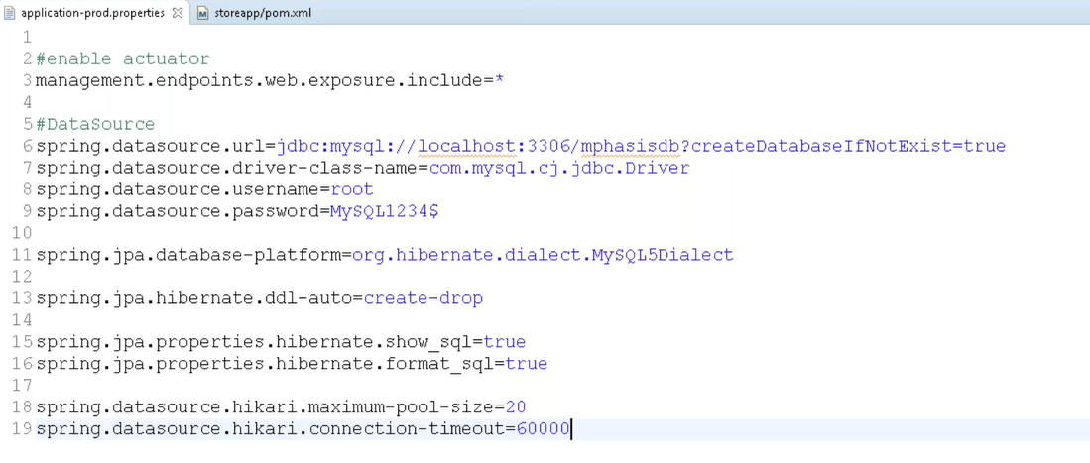

**Changing profiles in spring boot**

Got to run configurations -> add profile as dev/prod

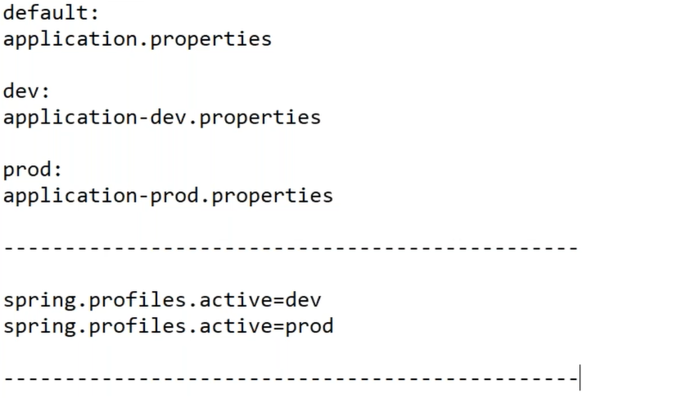

**VM arguments**

[**https://12factor.net**](https://12factor.net)

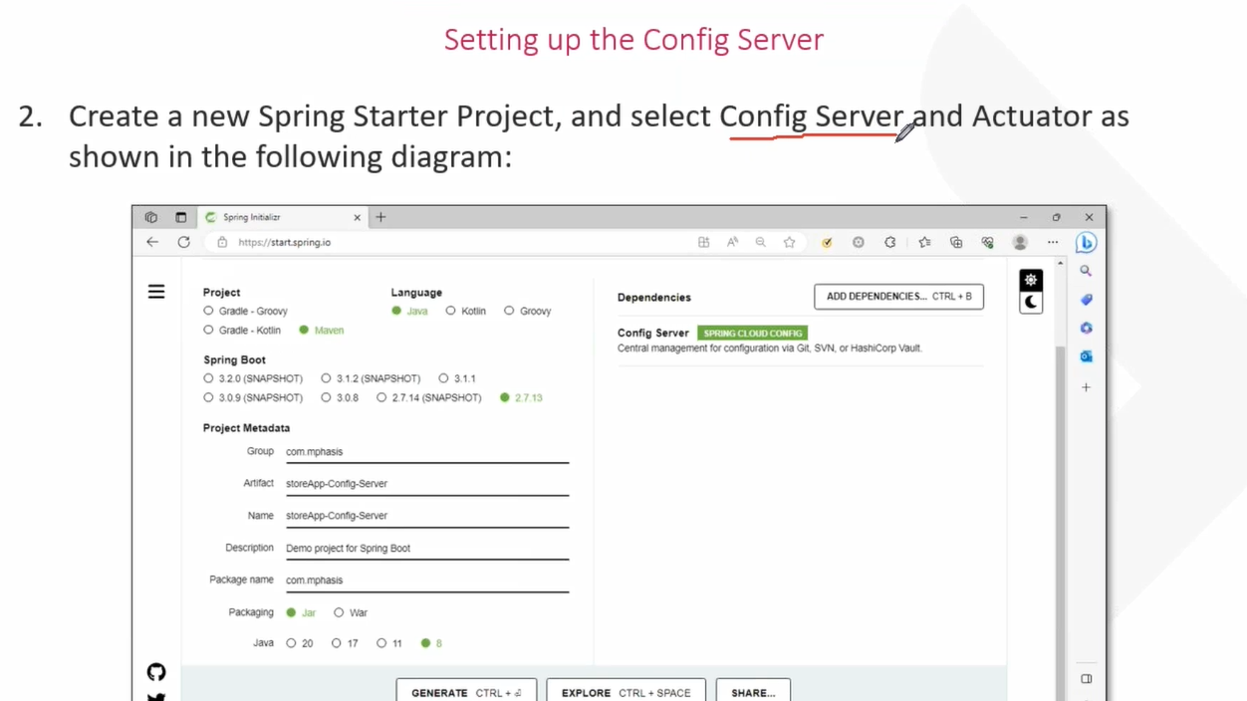

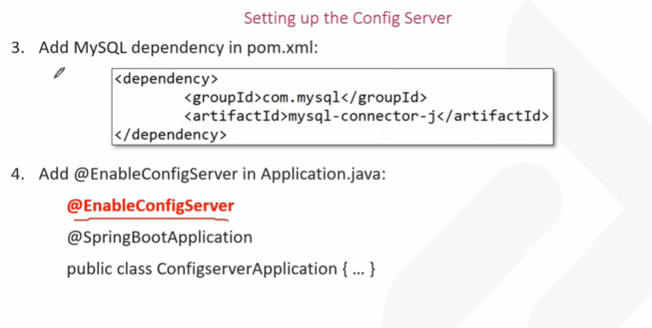

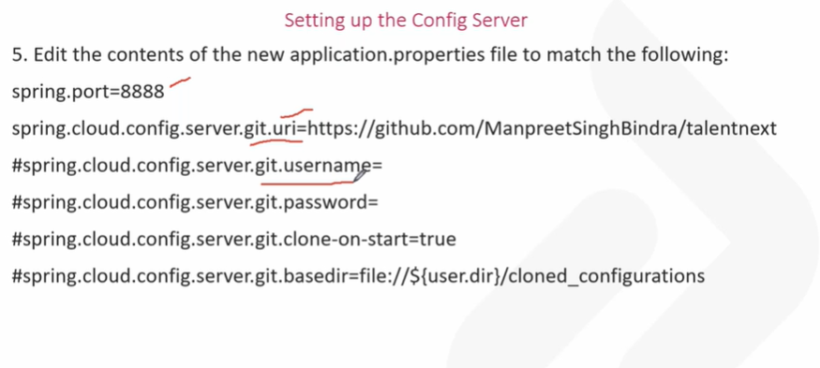

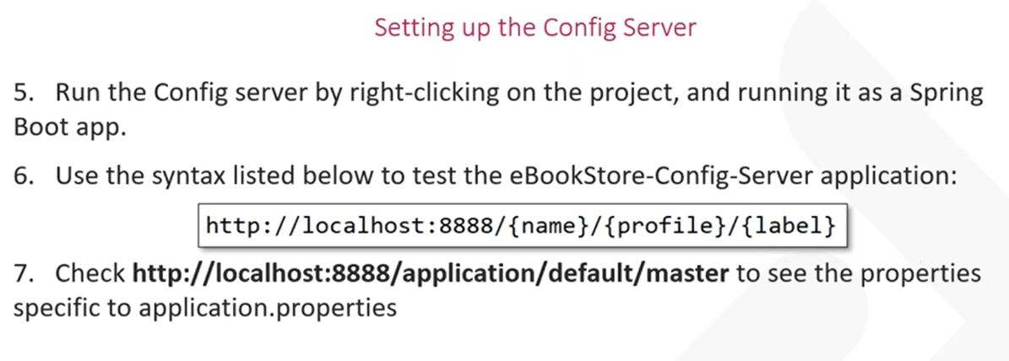

**Example: label is branch name**

**http://localhost:8888/application/dev/master**

**Storing the properties file in the spring project**

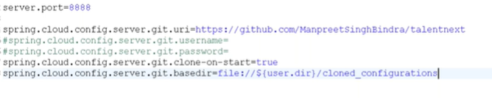

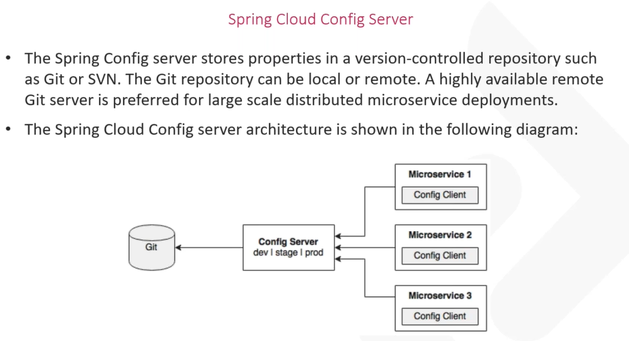

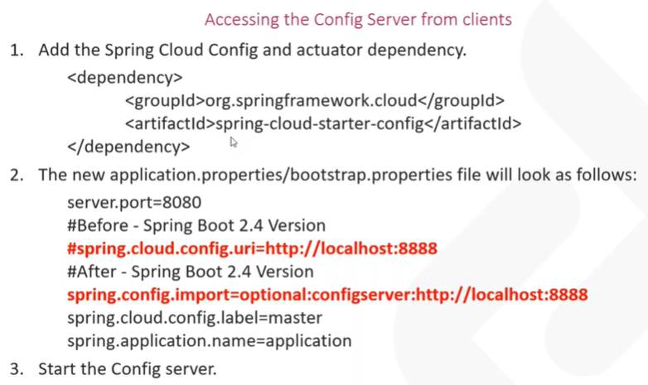

**Accessing files from config server to config client**

**---------------------------------------------Day3----------------------------------------**

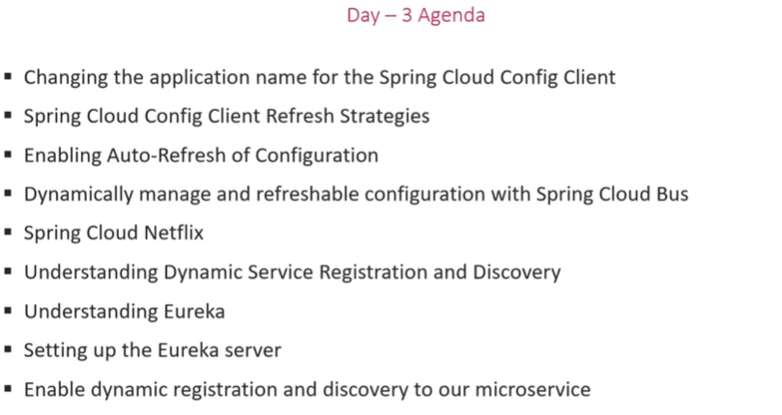

**1.changing the application name in properties file**

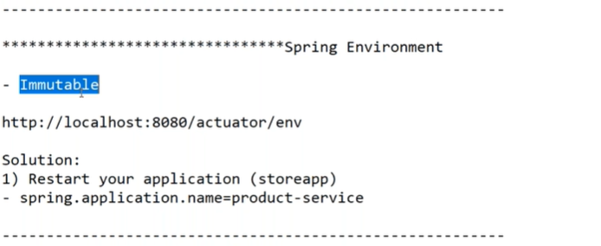

**2. Refreshing the properties without restarting the application**

**port number of postman is “config client”**

**pre-requisite - actuator dependency**

management.endpoints.web.exposure.include=*

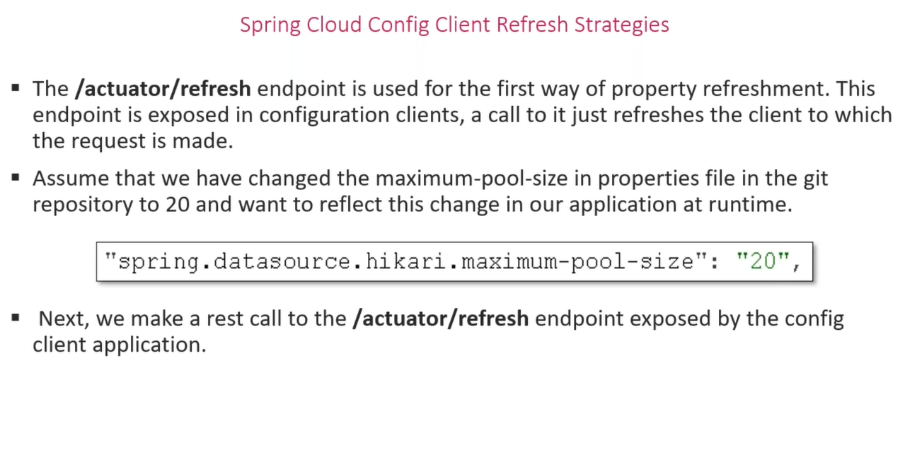

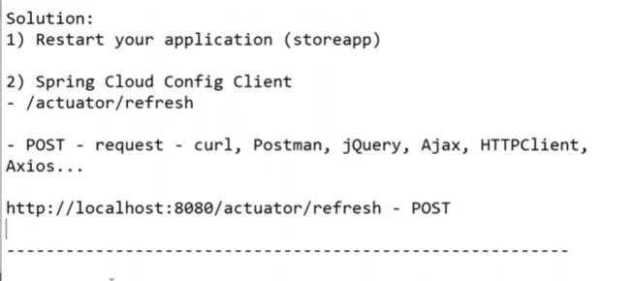

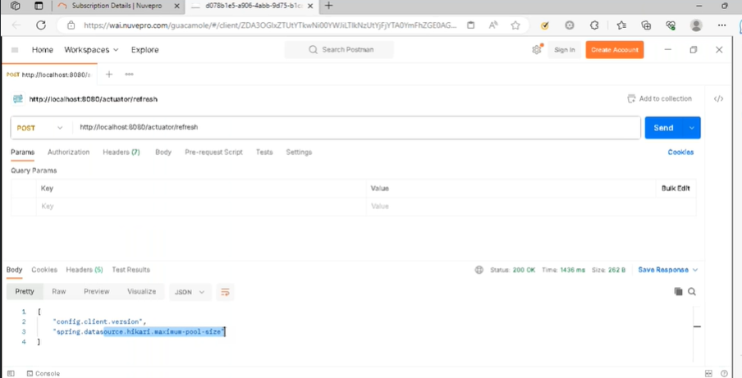

**3.**

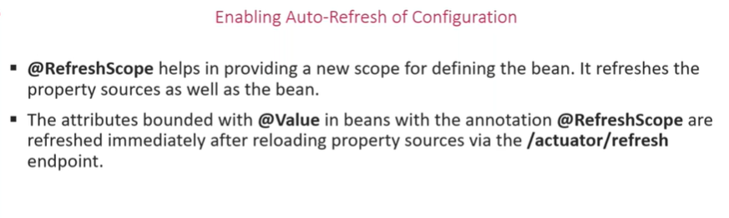

**Custom configuration of app.prop in prod**



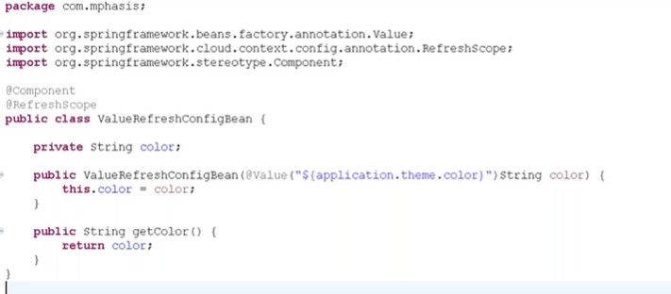

**4.spring cloud bus - rabbithq**

**Use:**

**Refreshing config server instead of config client**

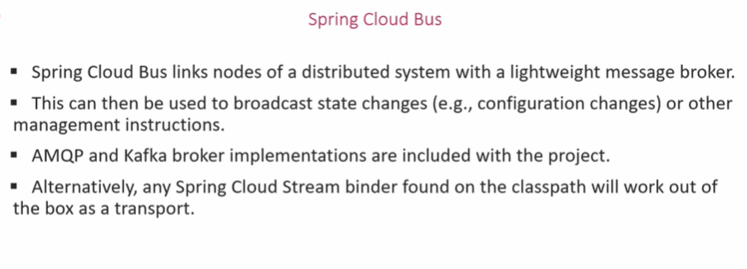

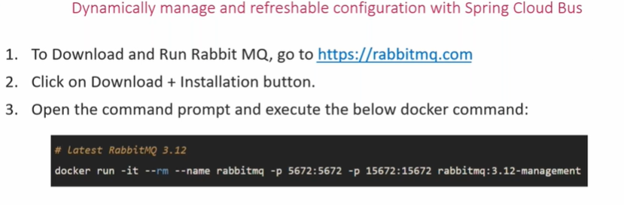

docker run -it --rm --name rabbitmq -p 5672:5672 -p 15672:15672 rabbitmq:3.12-management

**rabbitmq – id:**guest**, pass:**guest

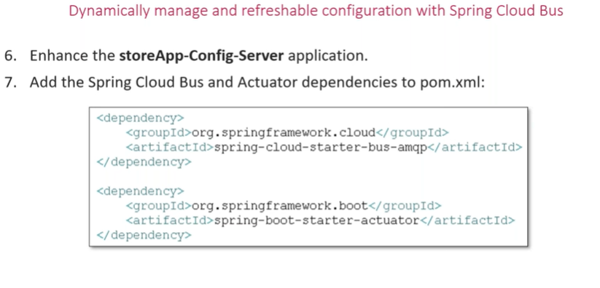

**Add the dependency in config server and config client**

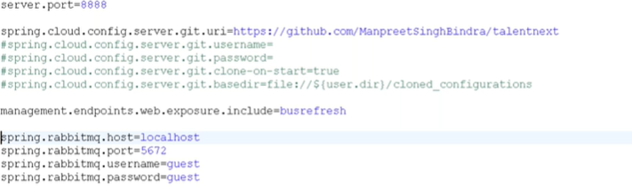

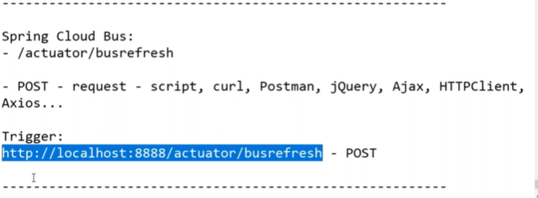

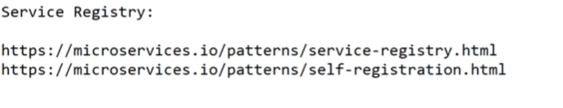

**5,6,7….**

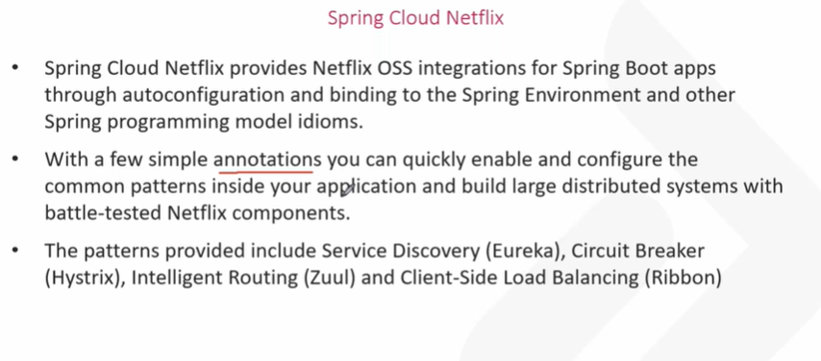

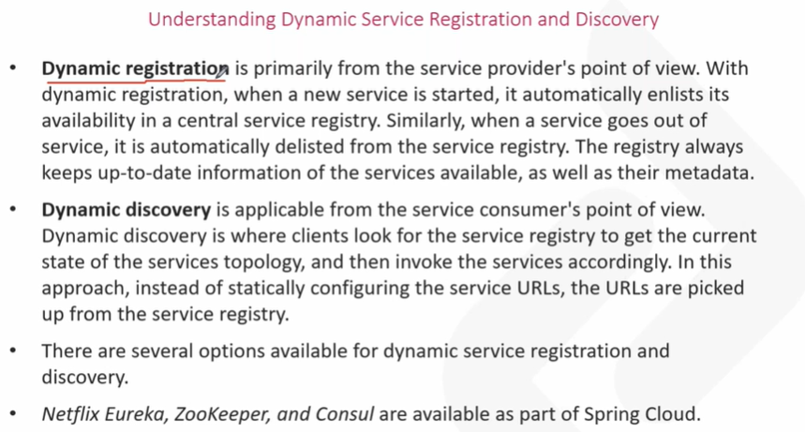

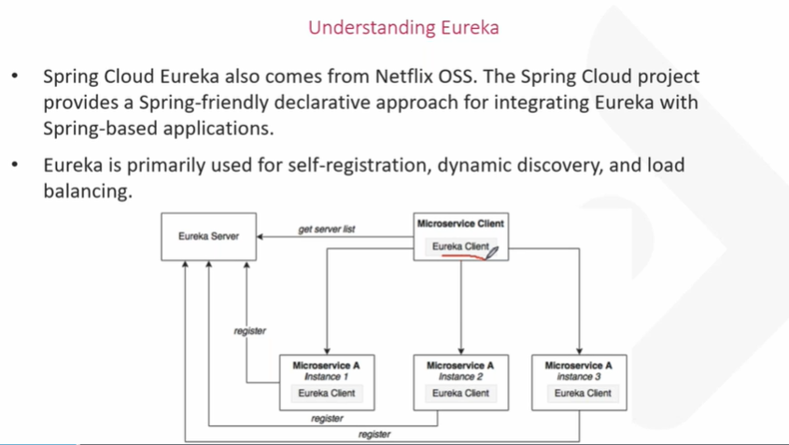

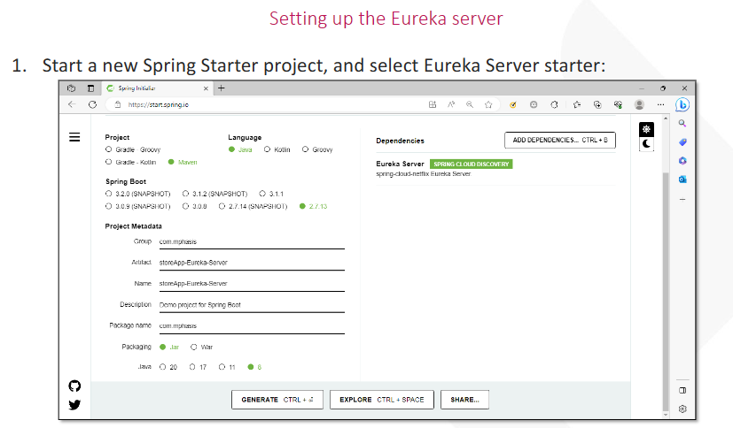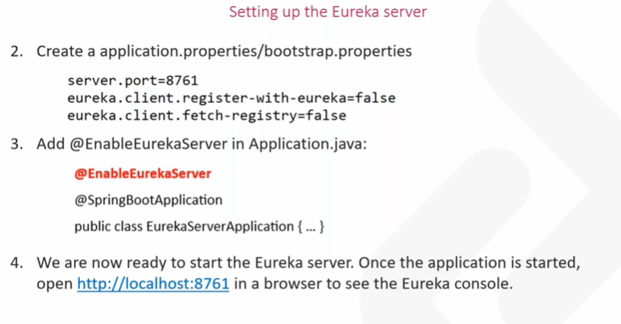

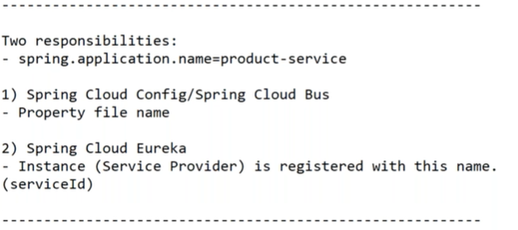

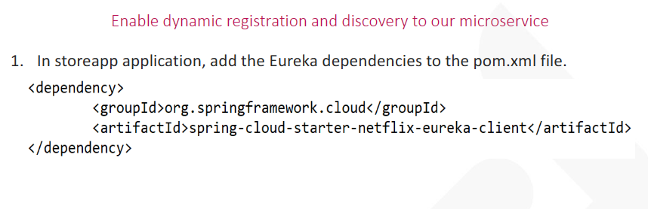

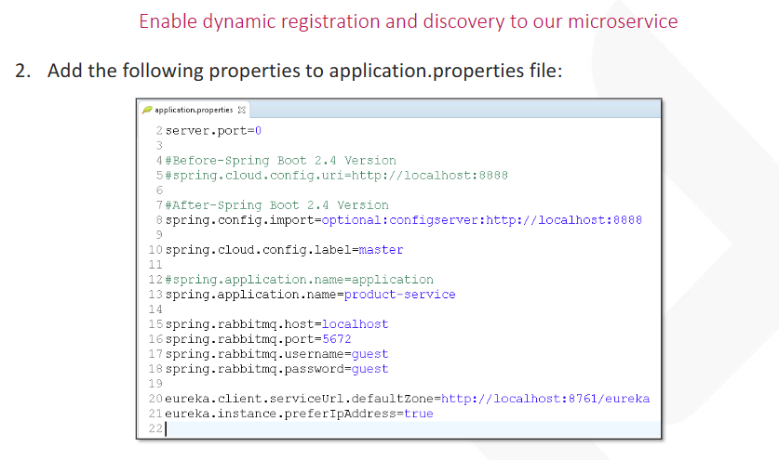 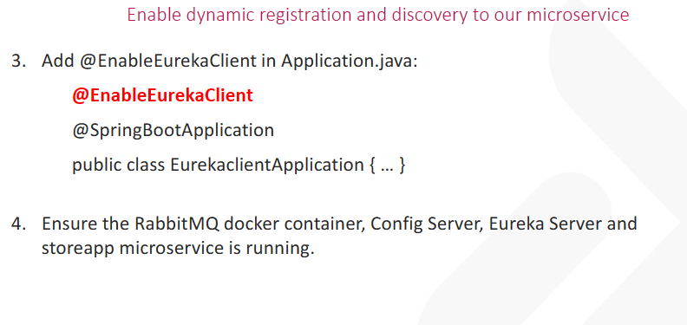

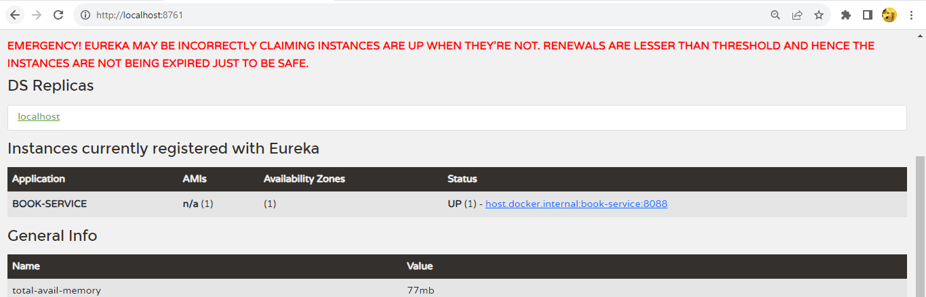

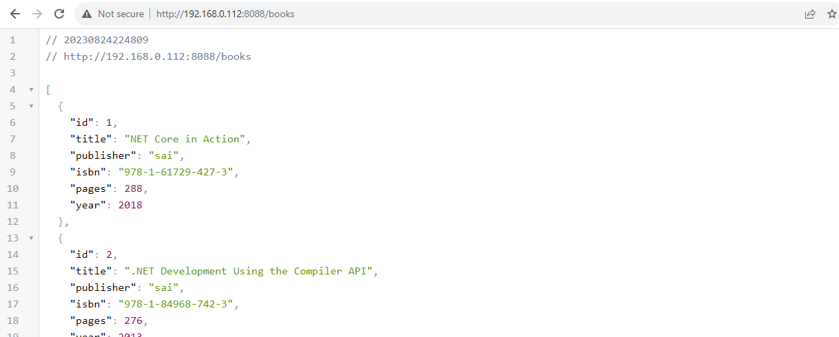

**--------------------------------------- Day4 -------------------------------------**

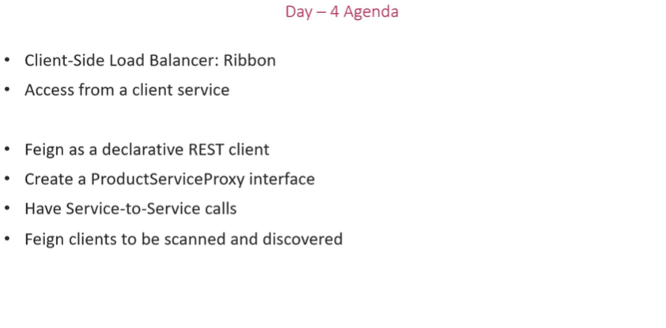

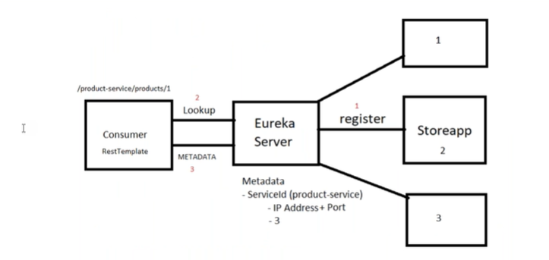

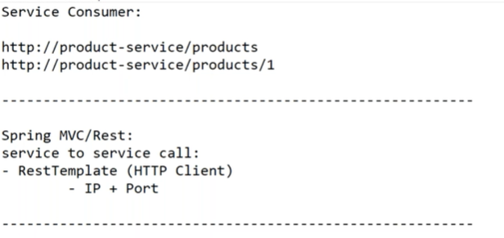

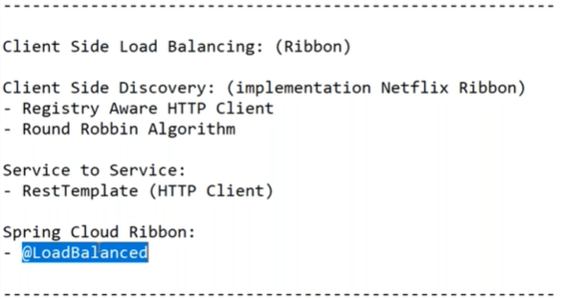

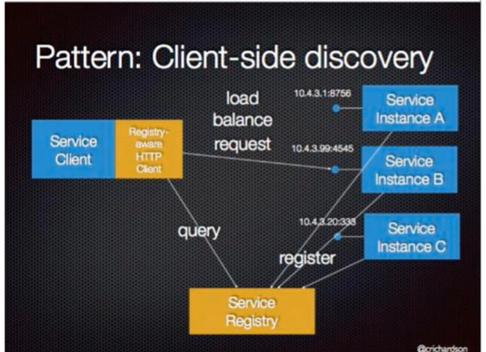

**Ribbon**

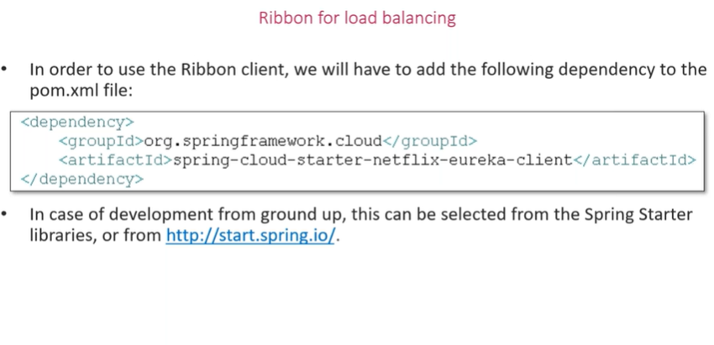

**Starter – eureka discovery client / eureka client**

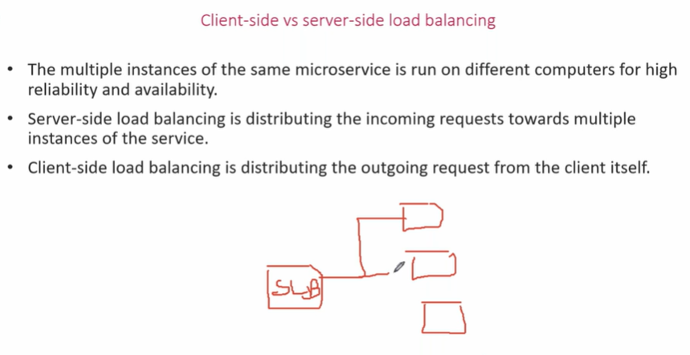

**Follows round ribbon algorithm**

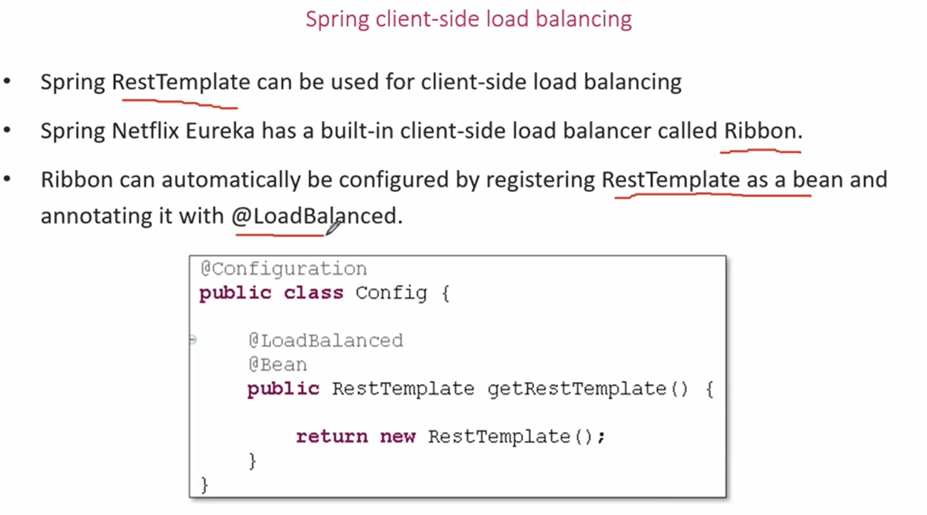

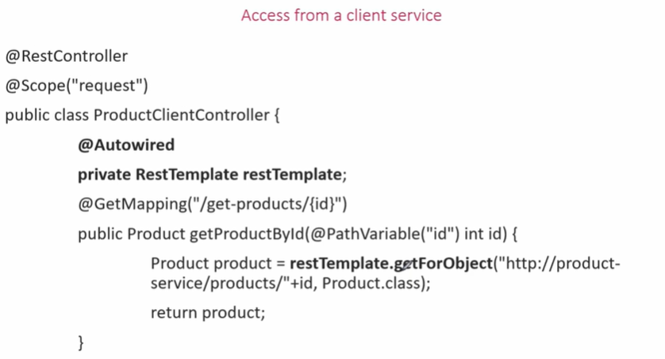

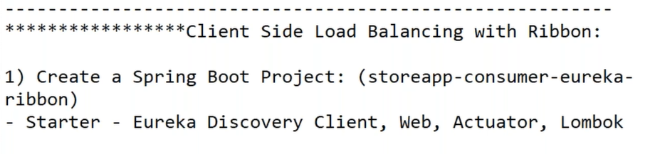

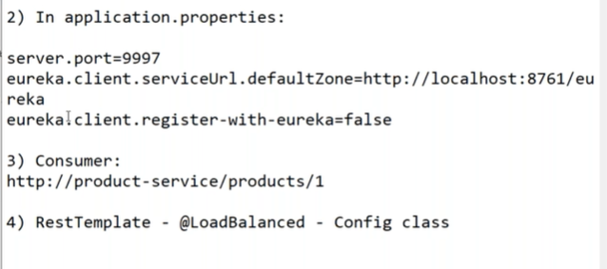

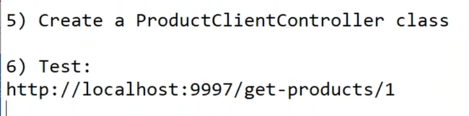

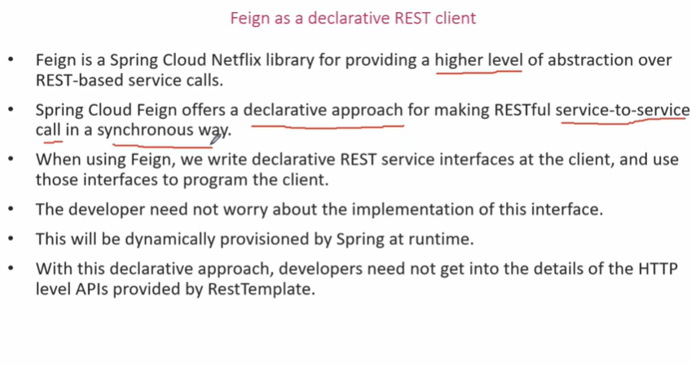

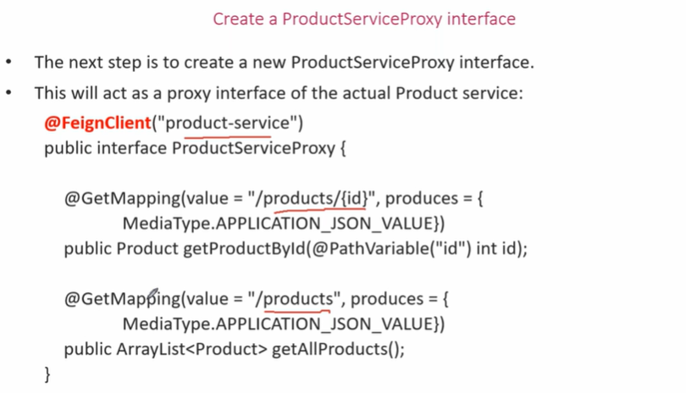

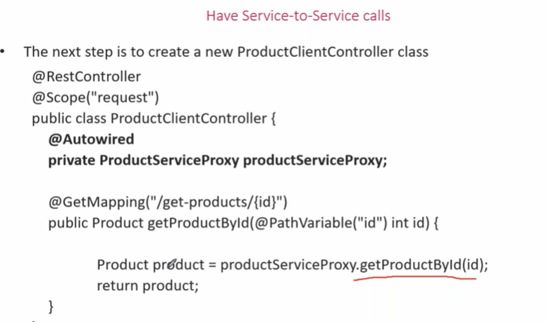

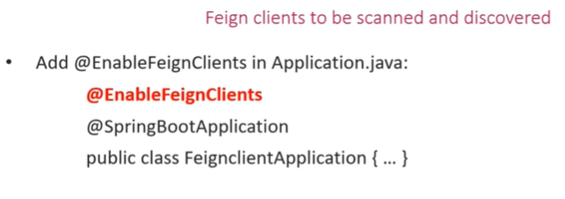

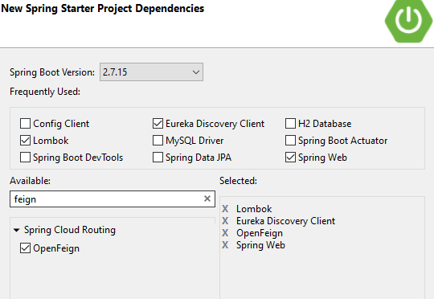

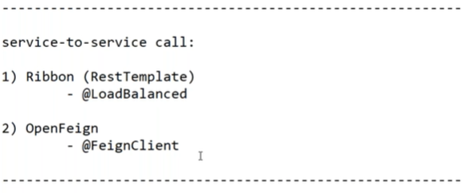

-------------------------------------- Day5 --------------------------------------------

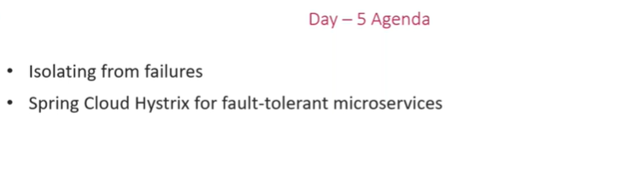

**Problem : failure of sevices**

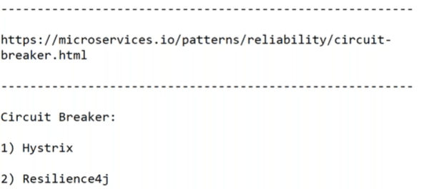

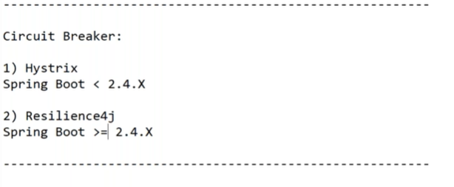

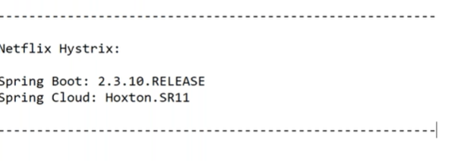

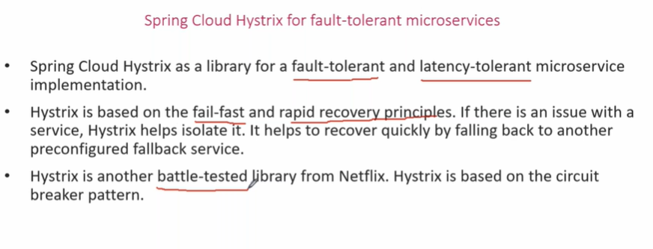

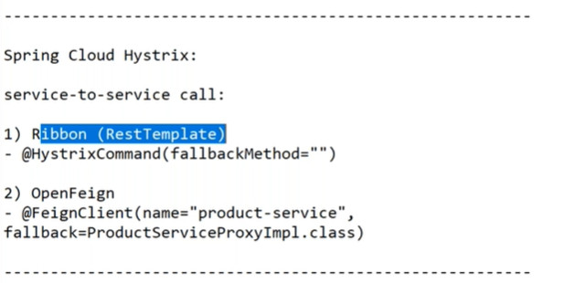

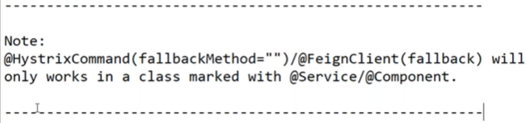

**For hystrix**:

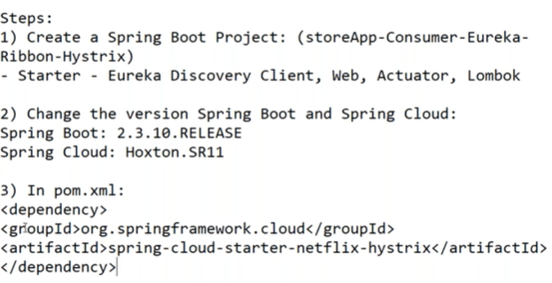

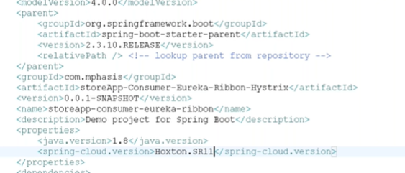

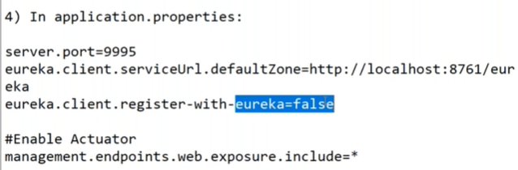

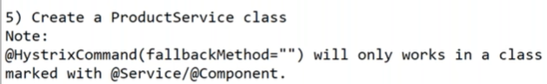

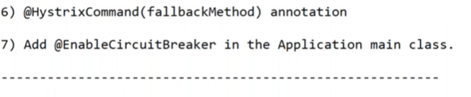

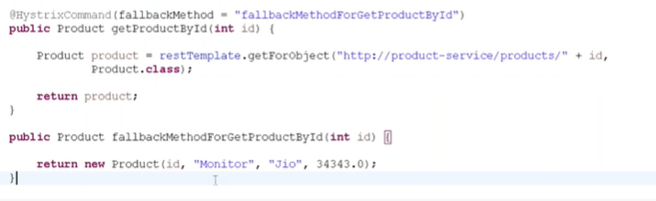

**For feign:**

1,2,3 same as hystrix

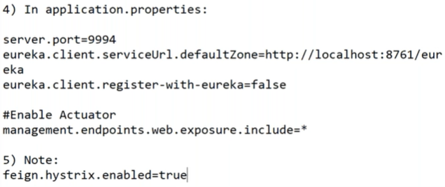

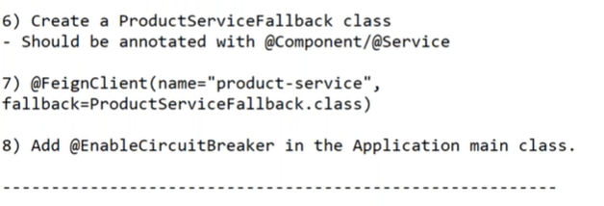

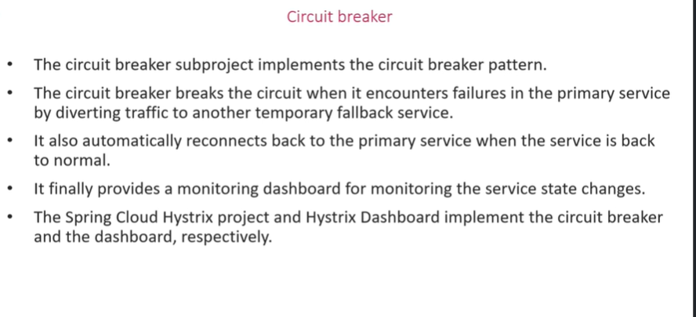

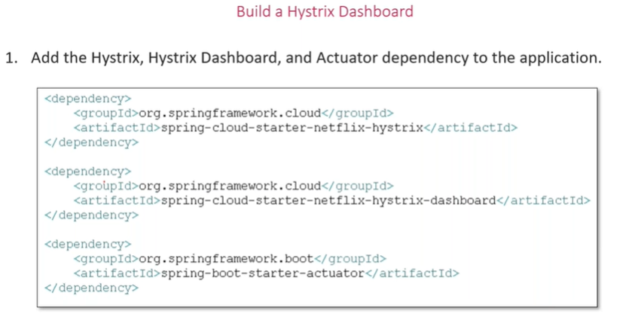

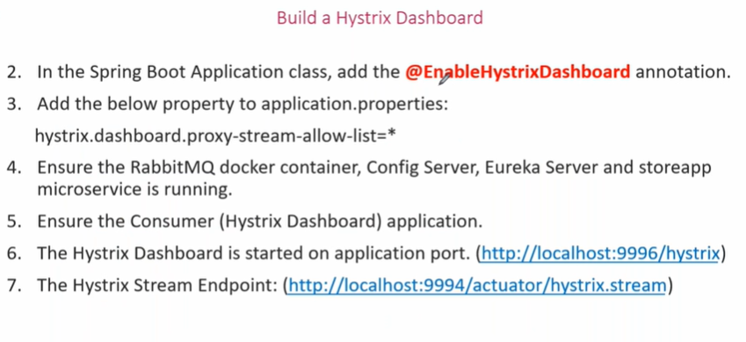

------------------------------------- Day6 ---------------------------------------------

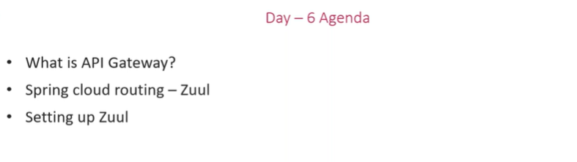

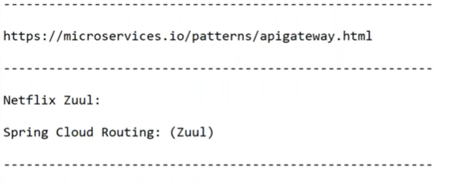

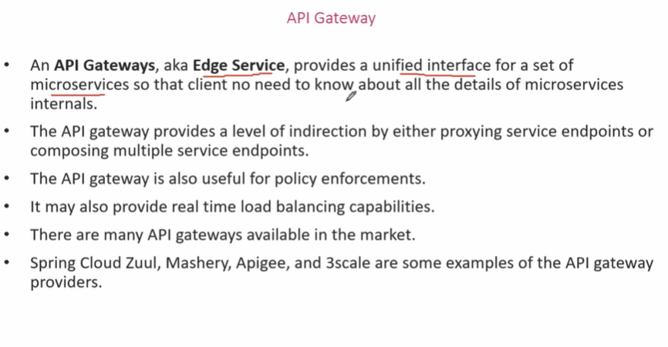

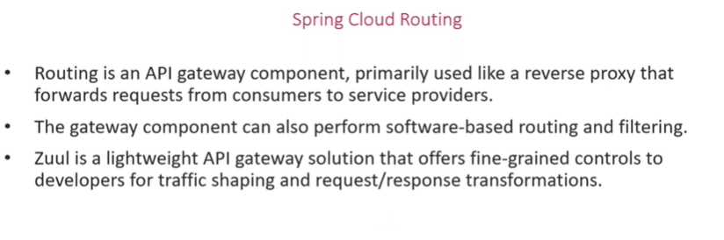

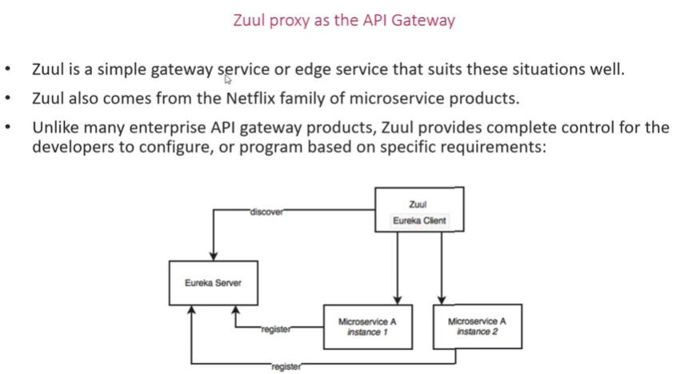

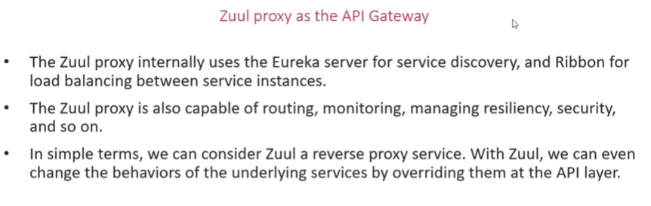

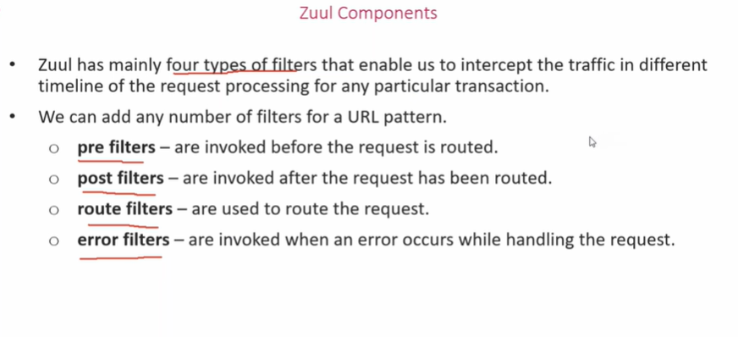

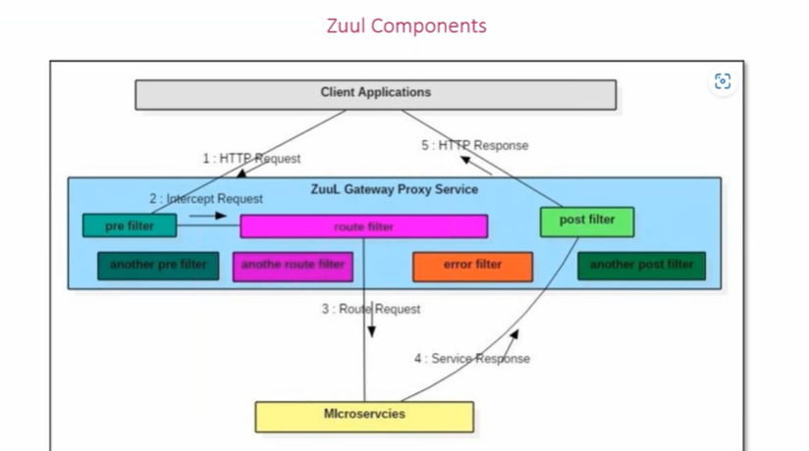

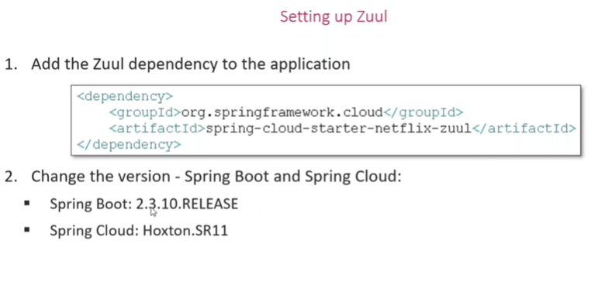

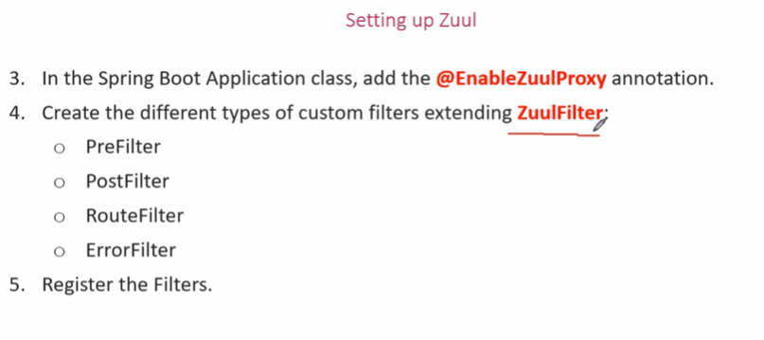

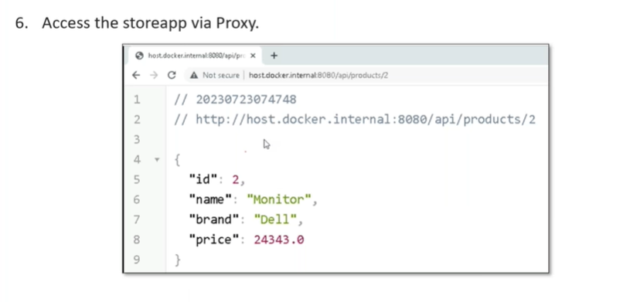

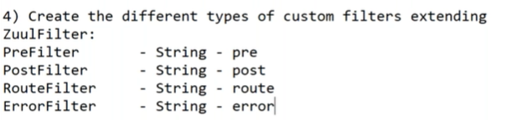

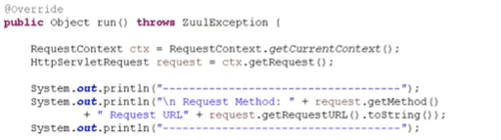

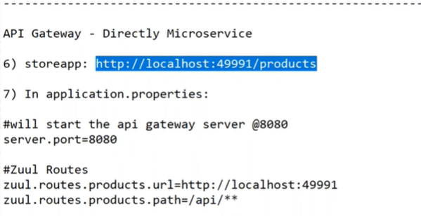

**url** – <http://localhost:49991/api/products>

<http://localhost:49991/api/products/1> etc.

**with eureka**

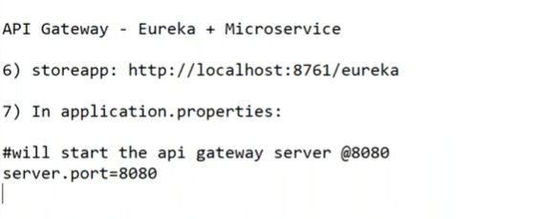

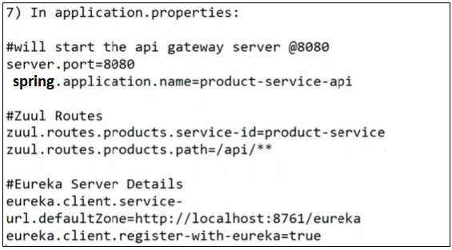

**------------------------------------- Day7 --------------------------------------------**

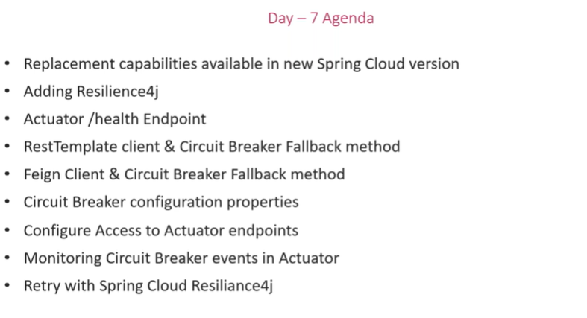

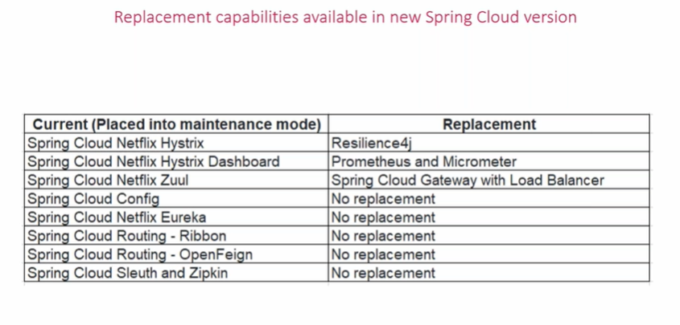

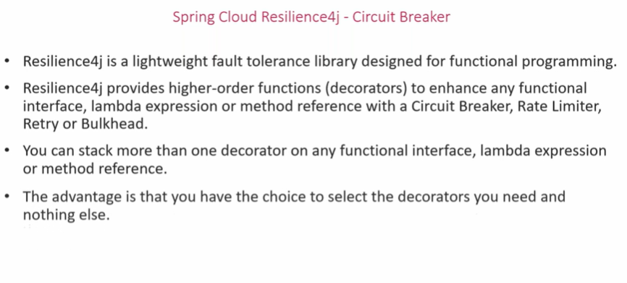

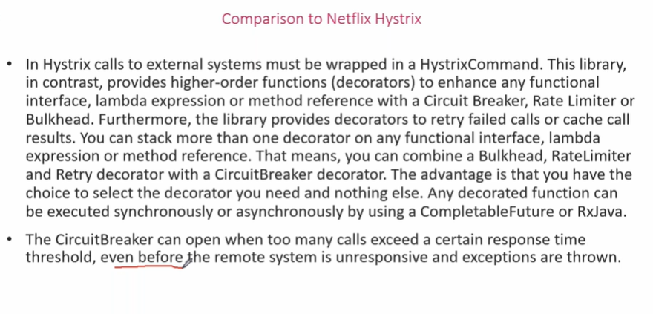

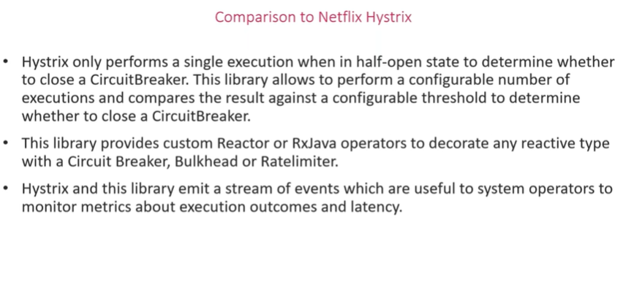

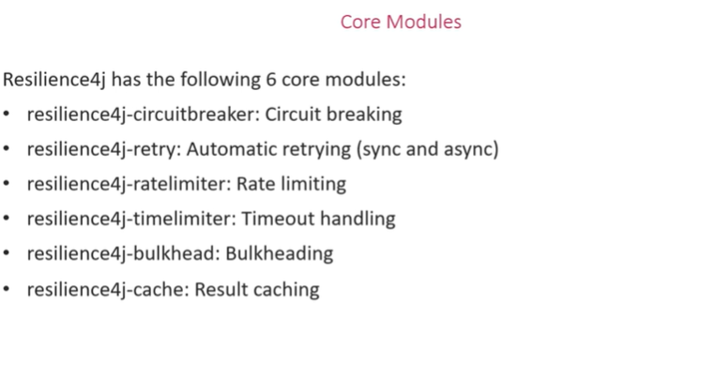

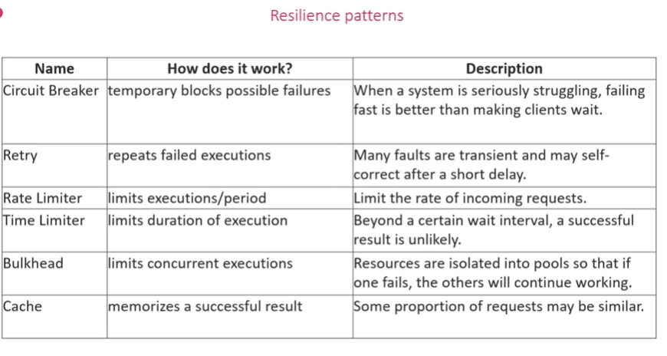

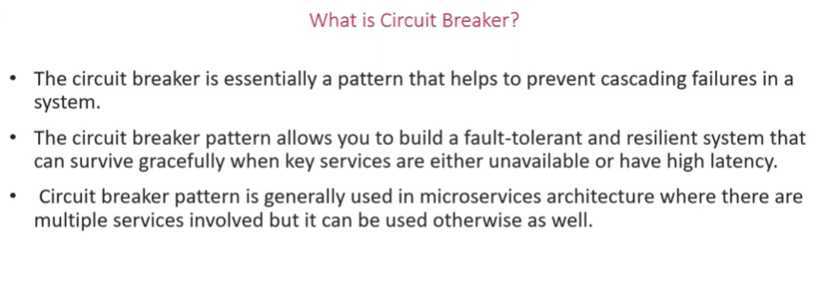

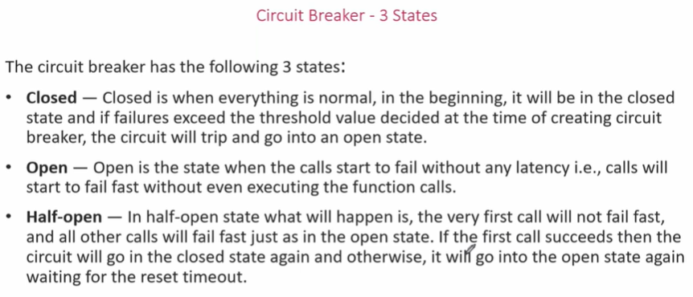

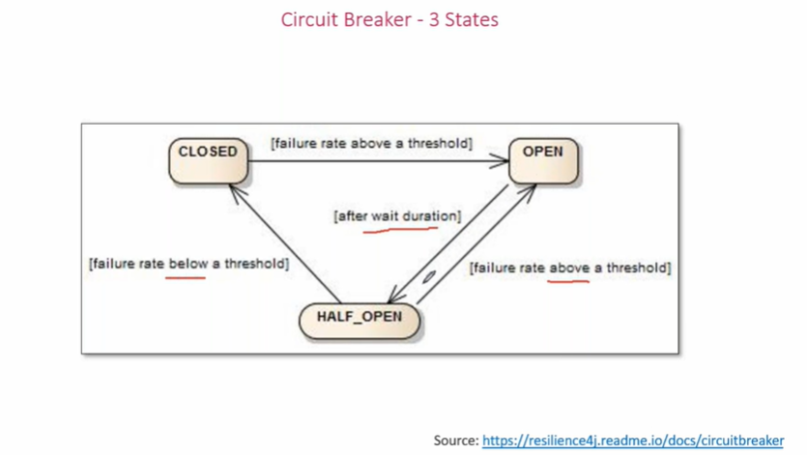

**With ribbon**

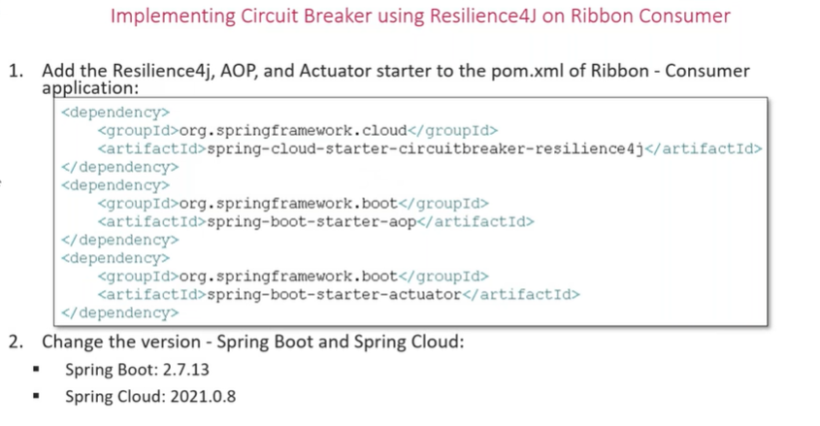

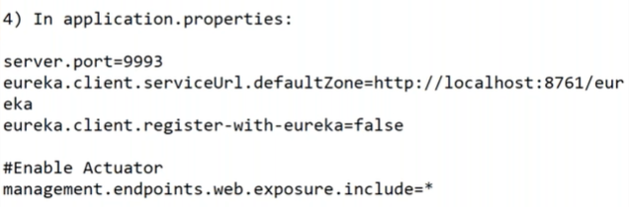

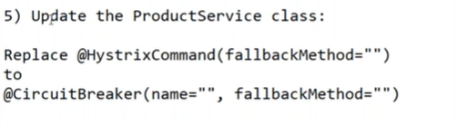

name=book-service

6) add an attribute throwable / exception to every fallback method

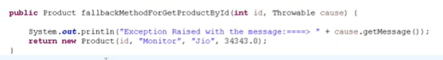

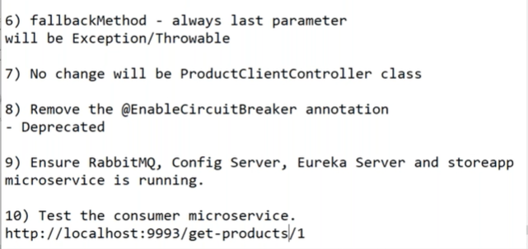

**With feign**

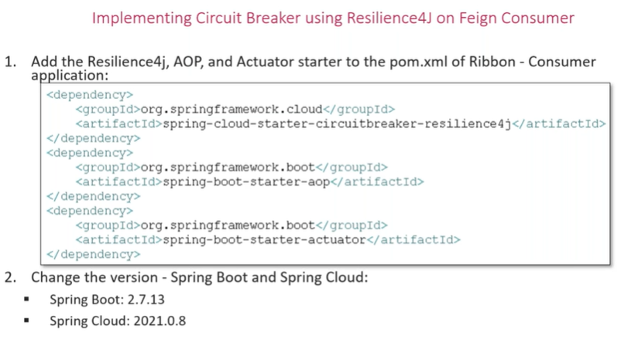

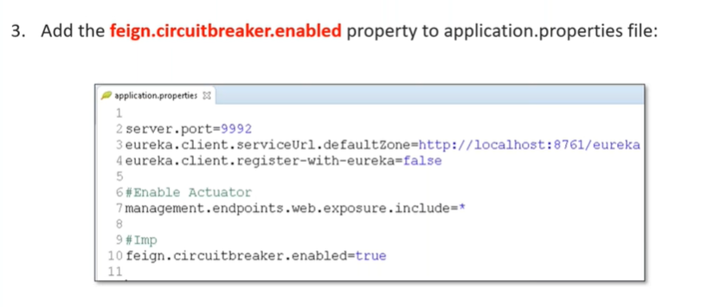

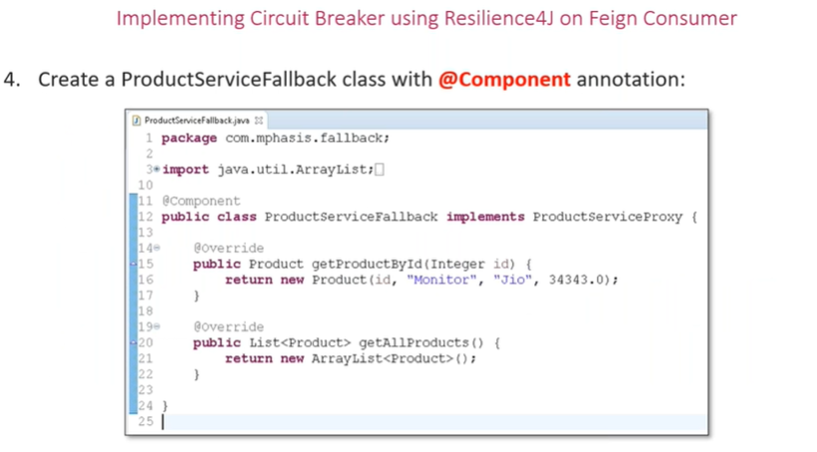

**4,5,6 –no changes**

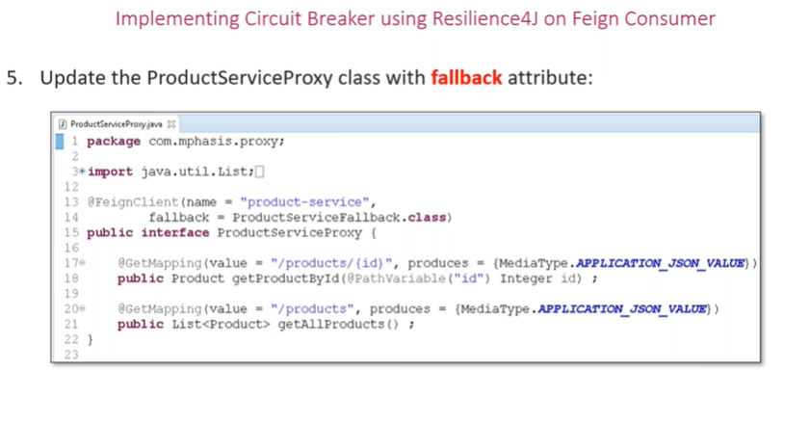

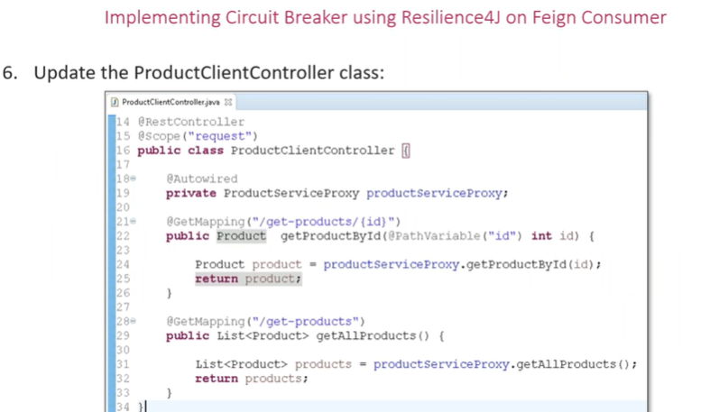

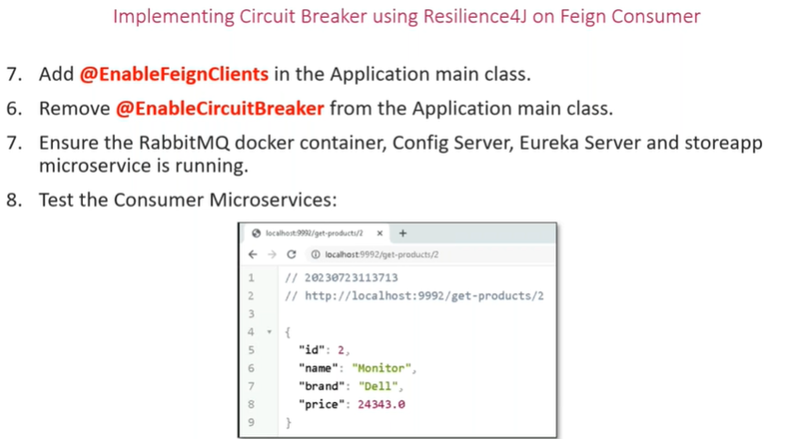

**Circuit breaker attributes:**

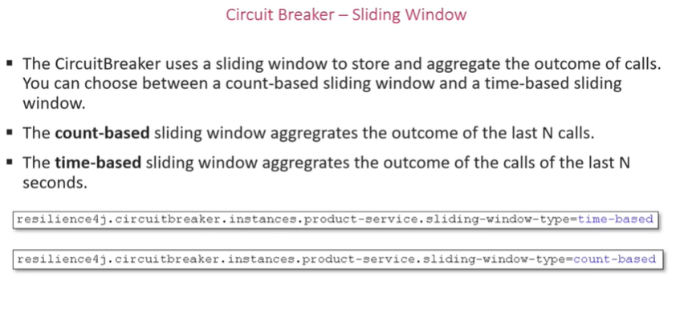

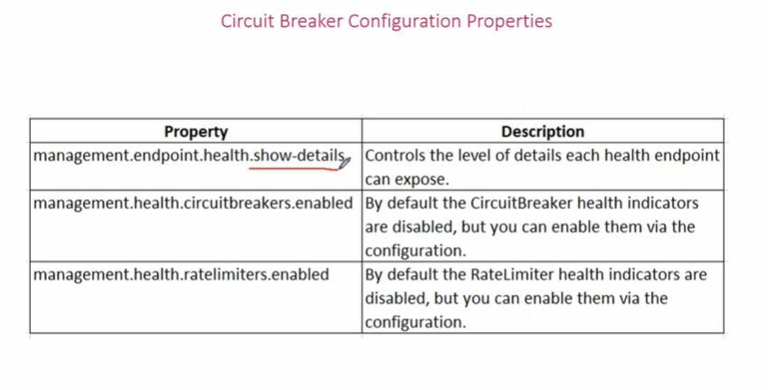

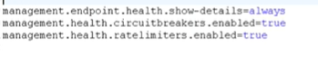

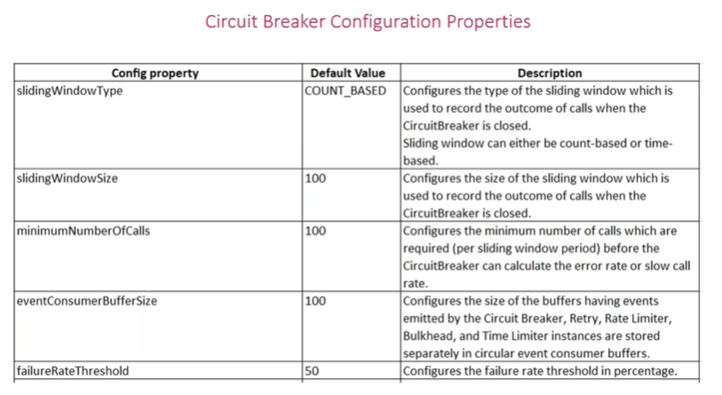

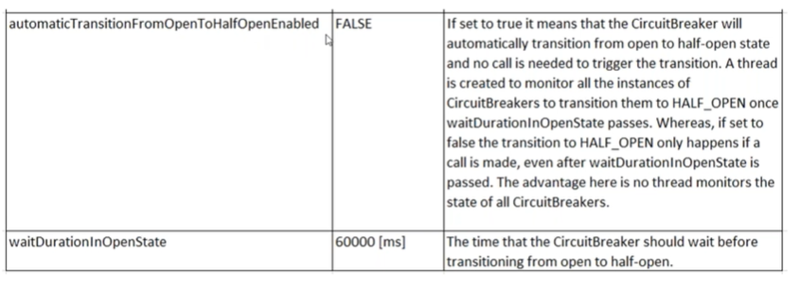

**For ribbon:**

**url- http://localhost:9004/actuator/circuitbreakerevents**

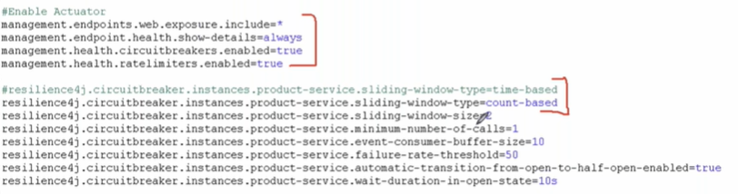

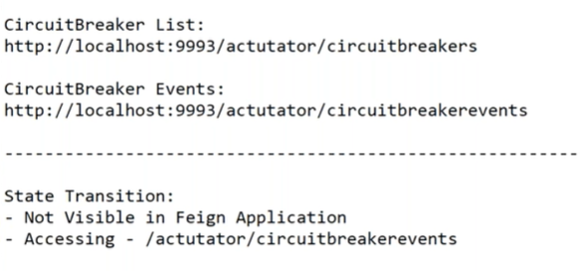

**For feign:**

Remove fallback class that extends interface of proxy,

And add its methods in the interface by making it as default method

🡪add @CircuitBreaker(name=””,fallBackMethod=””)above mappings

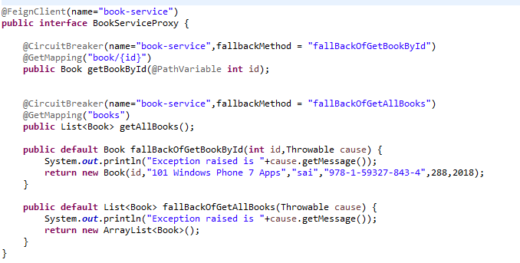

🡪application.properties remains same

#circuit breaker properties

management.endpoint.health.show-details=always

management.health.circuitbreakers.enabled=true

management.health.ratelimiters.enabled=true

resilience4j.circuitbreaker.instances.book-service.sliding-window-type=count-based

resilience4j.circuitbreaker.instances.book-service.sliding-window-size=2

resilience4j.circuitbreaker.instances.book-service.minimum-number-of-calls=1

resilience4j.circuitbreaker.instances.book-service.event-consumer-buffer-size=10

resilience4j.circuitbreaker.instances.book-service.failure-rate-threshold=50

resilience4j.circuitbreaker.instances.book-service.wait-duration-in-open-state=10s

resilience4j.circuitbreaker.instances.book-service.automatic-transition-from-open-

to-half-open-enabled=true

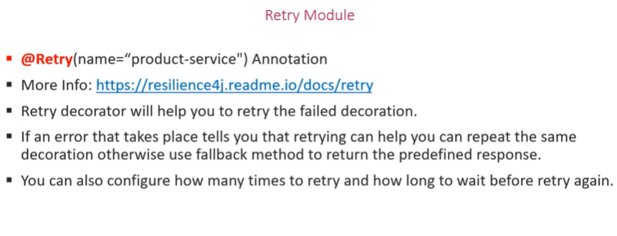

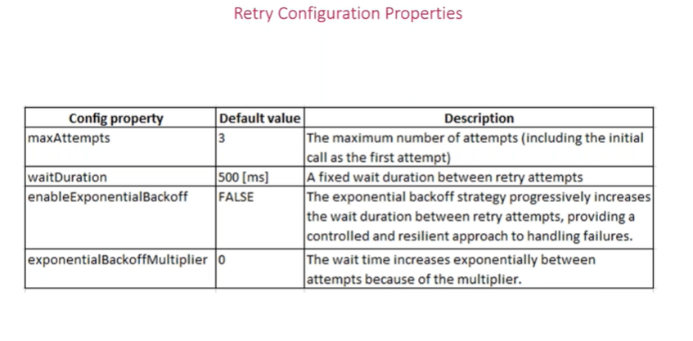

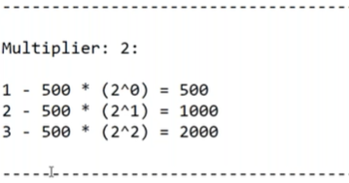

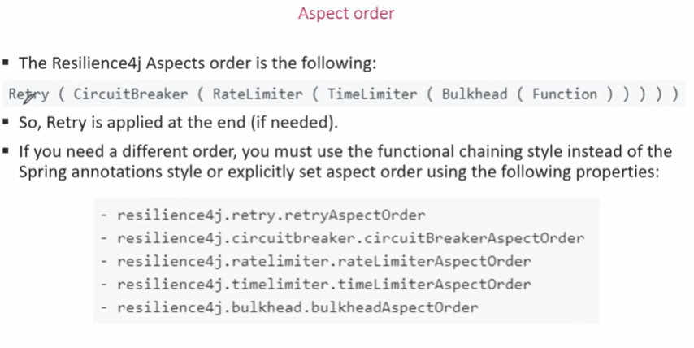

**On ribbon:**

**Application.properties**

server.port=9004

eureka.client.serviceUrl.defaultZone=http://localhost:8761/eureka

eureka.client.register-with-eureka=false

management.endpoints.web.exposure.include=*

#circuit breaker properties

resilience4j.circuitbreaker.circuit-breaker-aspect-order=1

management.endpoint.health.show-details=always

management.health.circuitbreakers.enabled=true

management.health.ratelimiters.enabled=true

resilience4j.circuitbreaker.instances.book-service.sliding-window-type=count-based

resilience4j.circuitbreaker.instances.book-service.sliding-window-size=2

resilience4j.circuitbreaker.instances.book-service.minimum-number-of-calls=1

resilience4j.circuitbreaker.instances.book-service.event-consumer-buffer-size=10

resilience4j.circuitbreaker.instances.book-service.failure-rate-threshold=50

resilience4j.circuitbreaker.instances.book-service.wait-duration-in-open-state=10s

resilience4j.circuitbreaker.instances.book-service.automatic-transition-from-open-to-half-open-enabled=true

resilience4j.retry.retry-aspect-order=2

resilience4j.retry.instances.book-service.max-attempts=3

resilience4j.retry.instances.book-service.wait-duration=2s

resilience4j.retry.instances.book-service.enable-exponential-backoff=true

resilience4j.retry.instances.book-service.exponential-backoff-multiplier=5

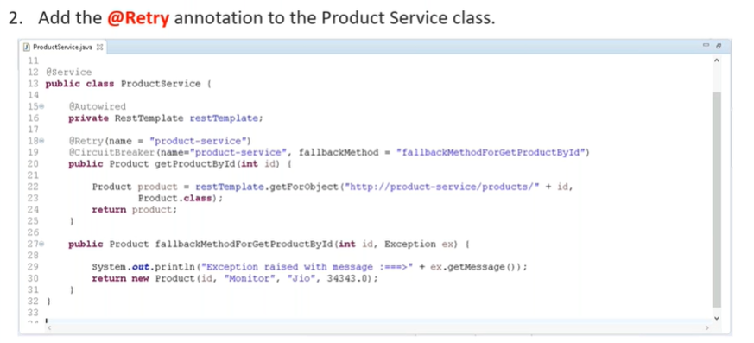

**on feign**:

**application.properties**

server.port=9004

eureka.client.serviceUrl.defaultZone=http://localhost:8761/eureka

eureka.client.register-with-eureka=false

management.endpoints.web.exposure.include=*

#imp

feign.circuitbreaker.enabled=true

#circuit breaker properties

resilience4j.circuitbreaker.circuit-breaker-aspect-order=1

management.endpoint.health.show-details=always

management.health.circuitbreakers.enabled=true

management.health.ratelimiters.enabled=true

resilience4j.circuitbreaker.instances.book-service.sliding-window-type=count-based

resilience4j.circuitbreaker.instances.book-service.sliding-window-size=2

resilience4j.circuitbreaker.instances.book-service.minimum-number-of-calls=1

resilience4j.circuitbreaker.instances.book-service.event-consumer-buffer-size=10

resilience4j.circuitbreaker.instances.book-service.failure-rate-threshold=50

resilience4j.circuitbreaker.instances.book-service.wait-duration-in-open-state=10s

resilience4j.circuitbreaker.instances.book-service.automatic-transition-from-open-to-half-open-enabled=true

resilience4j.retry.retry-aspect-order=2

resilience4j.retry.instances.book-service.max-attempts=3

resilience4j.retry.instances.book-service.wait-duration=2s

resilience4j.retry.instances.book-service.enable-exponential-backoff=true

resilience4j.retry.instances.book-service.exponential-backoff-multiplier=5

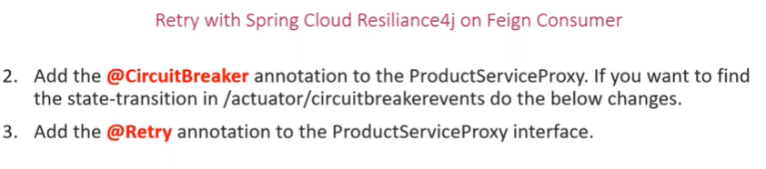

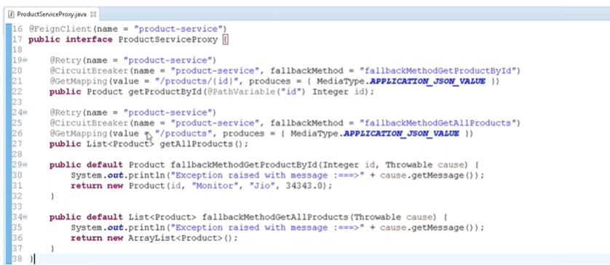

url – <http://localhost:9004/actuator/retryevents>

--------------------------------Day8-------------------------------------------------

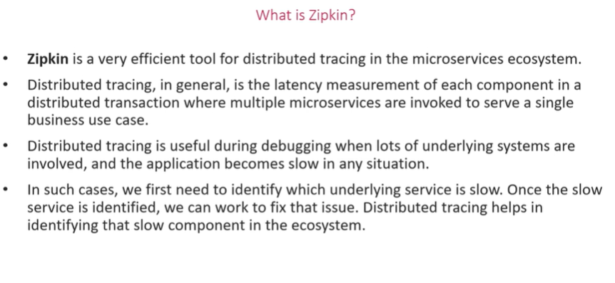

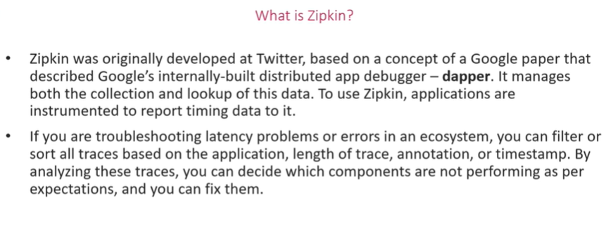

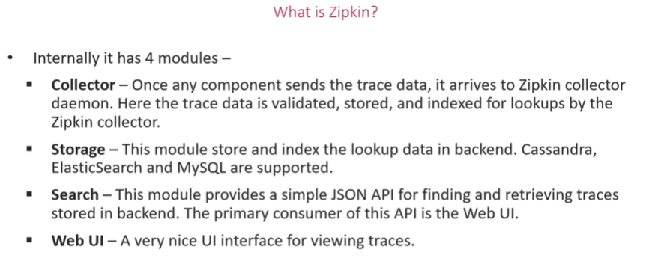

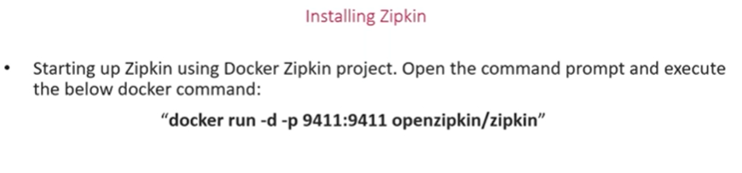

**docker run –p 9411:9411 openzipkin/zipkin**

**url-** [**http://127.0.0.1:9411/zipkin/**](http://127.0.0.1:9411/zipkin/)

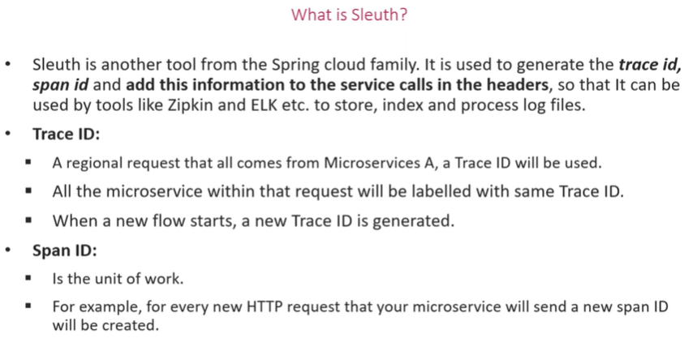

**Ribbon:**

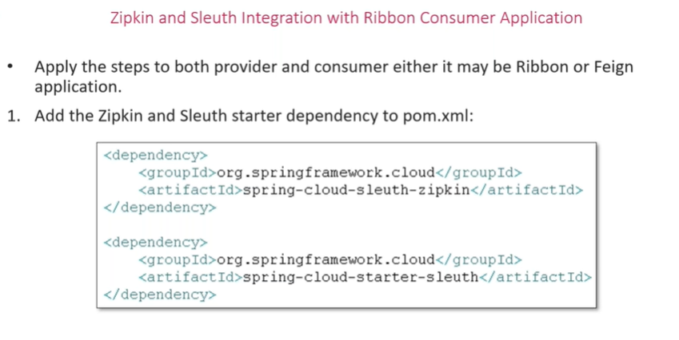

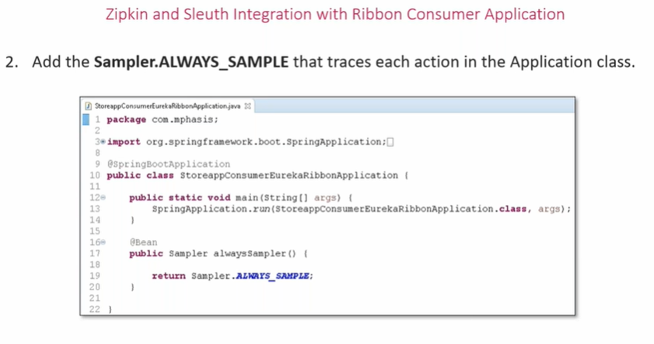

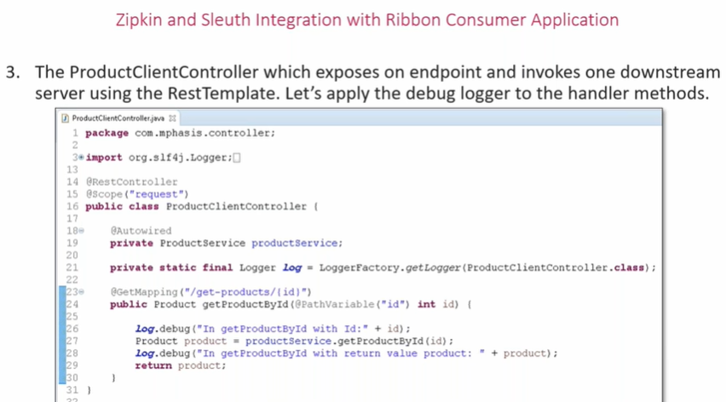

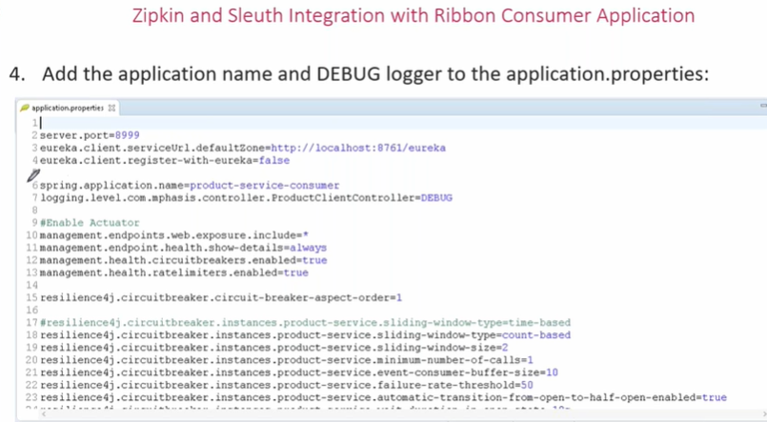

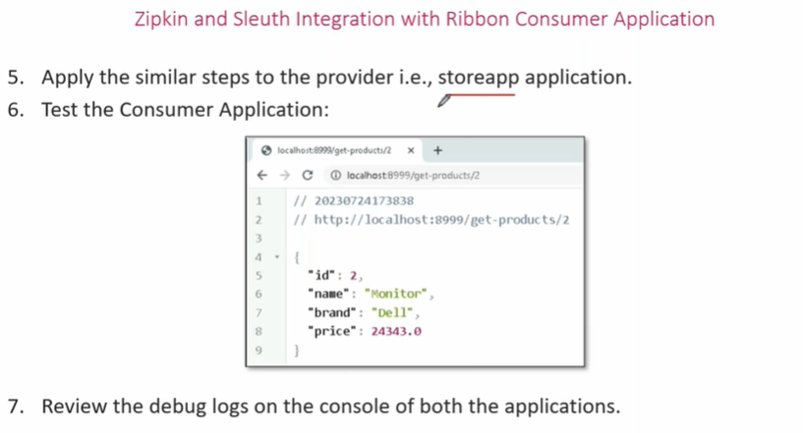

**Feign:**

**Same as ribbon**

**Zipkin with ribbon/feign implementation**

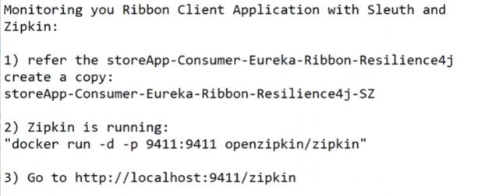

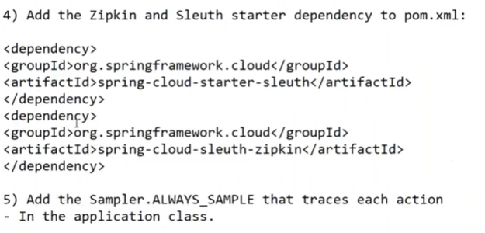

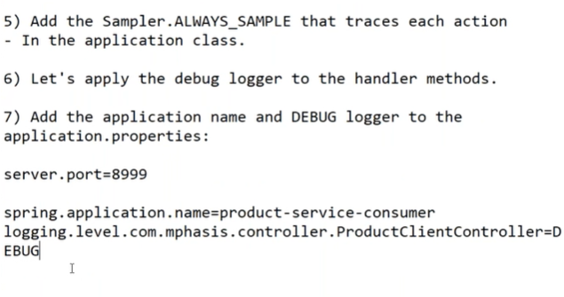

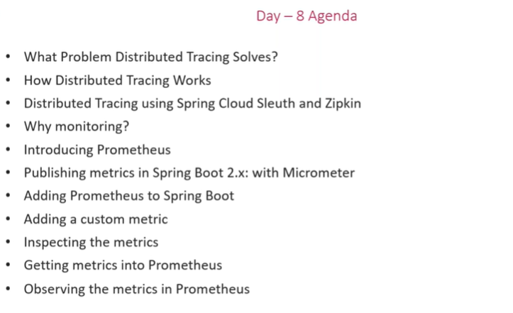

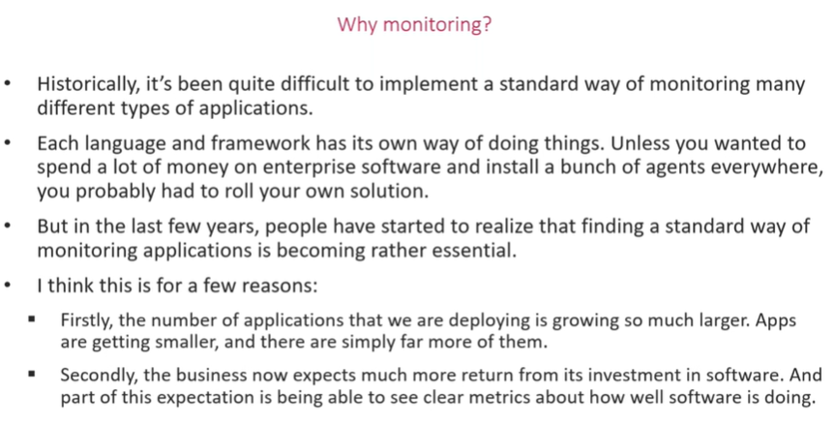

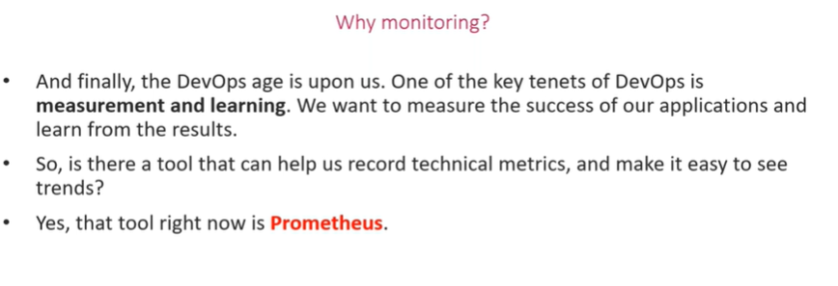

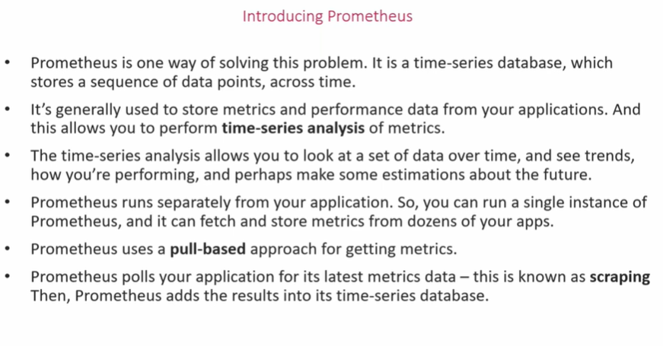

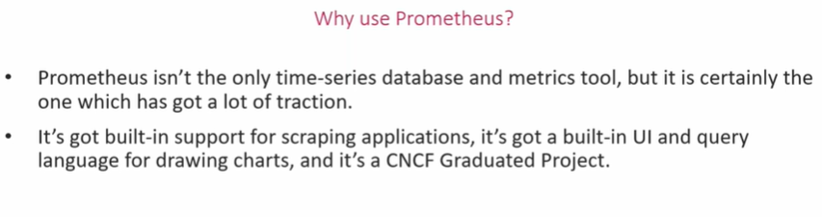



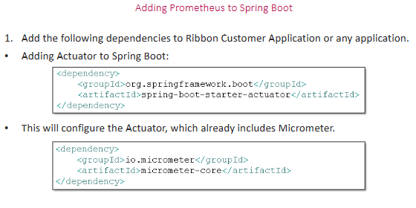

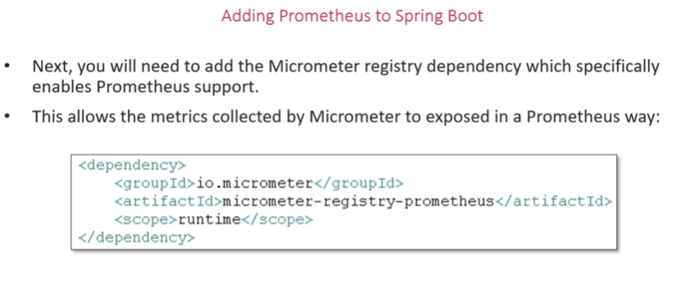

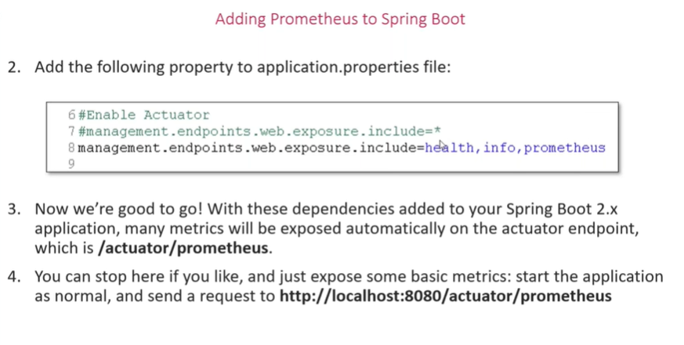

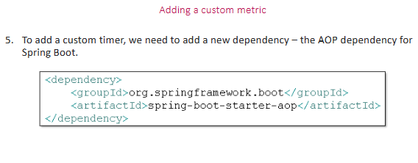

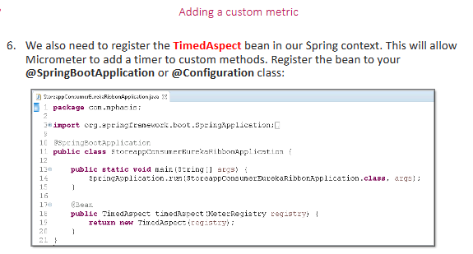

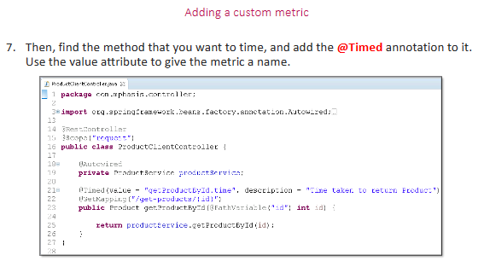

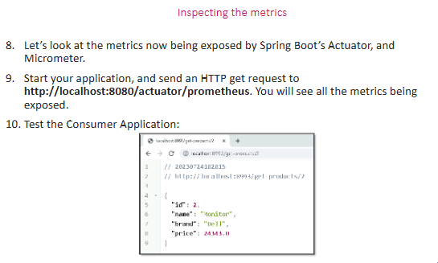

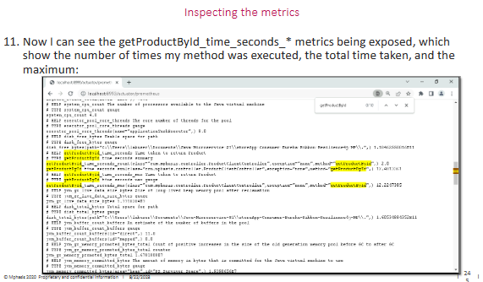

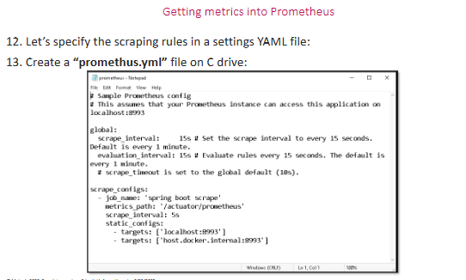

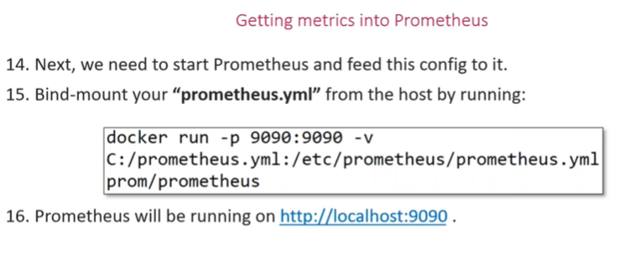

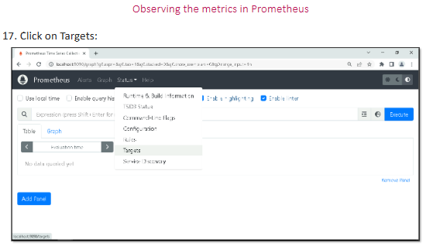

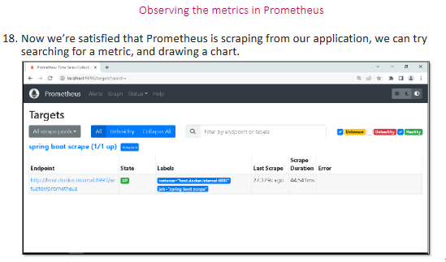

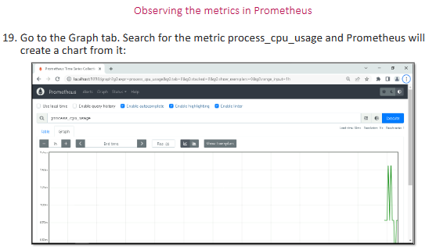

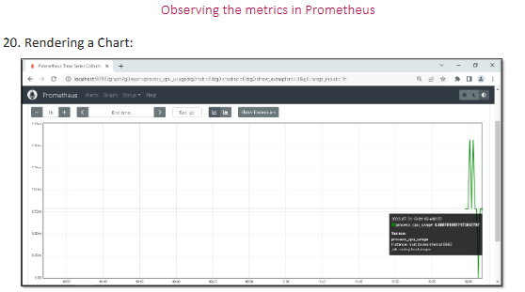

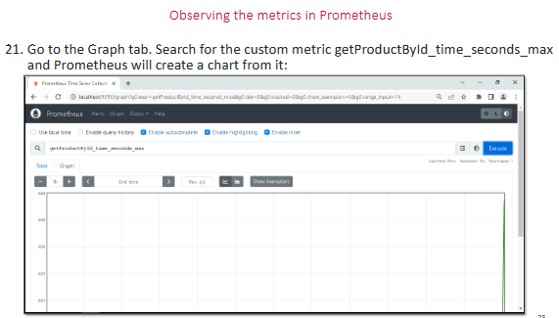

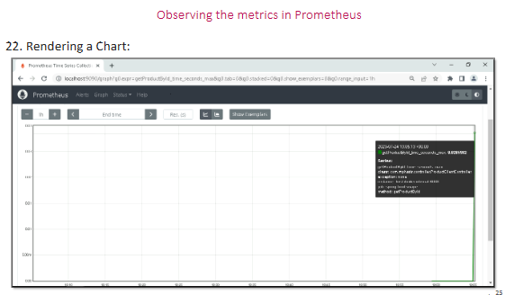

**---------------------------------Day9--------------------------------------**

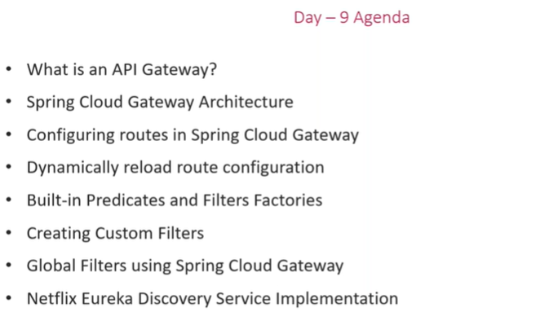

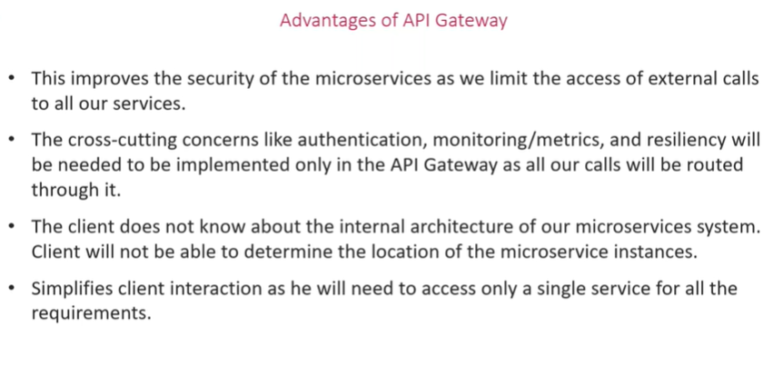

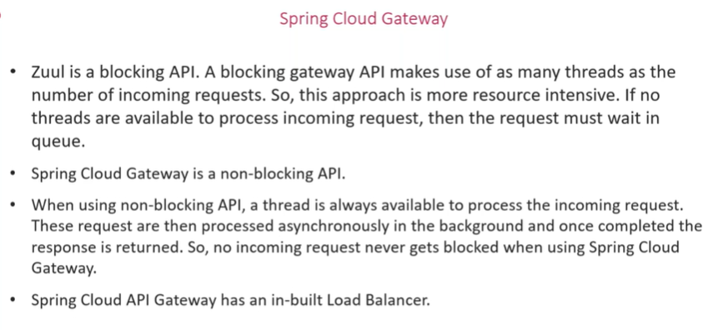

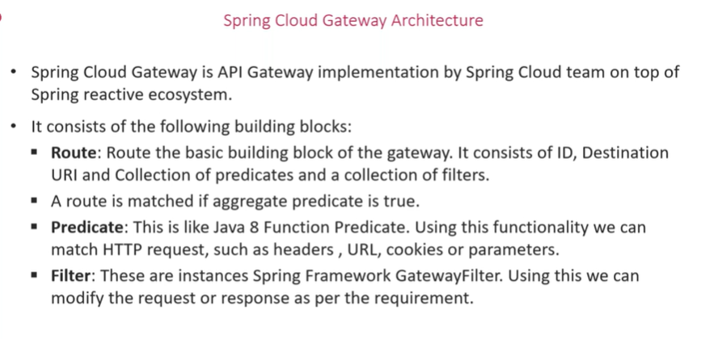

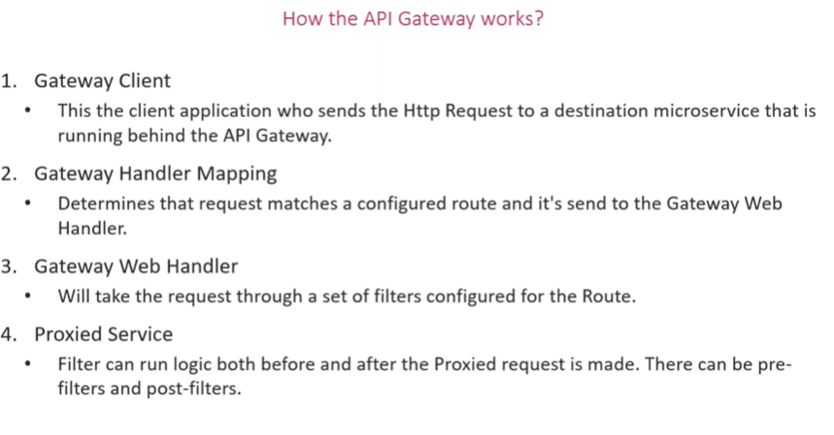

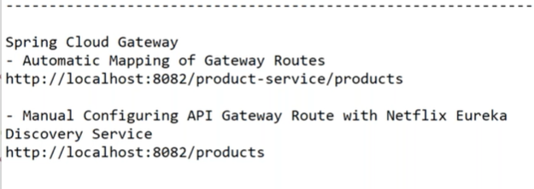

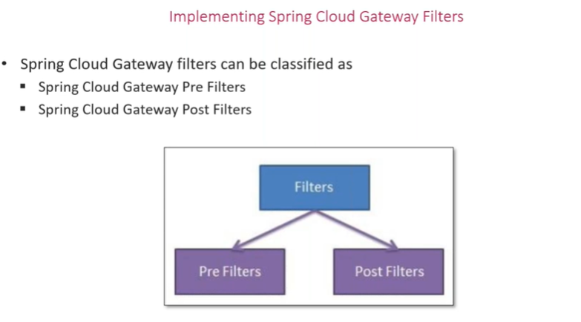

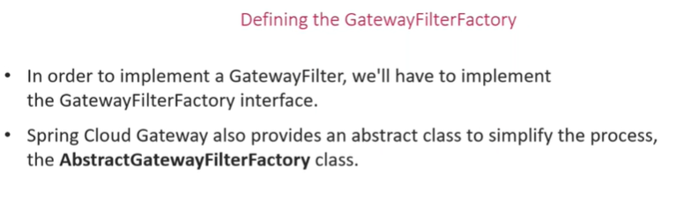

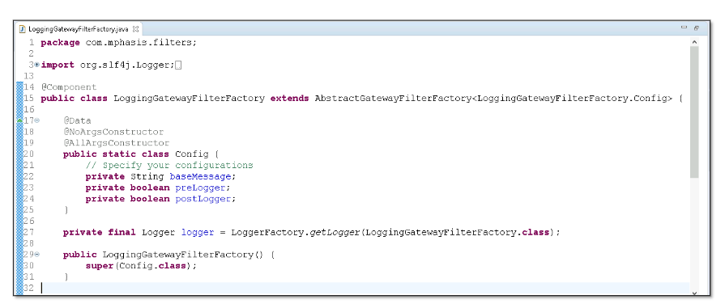

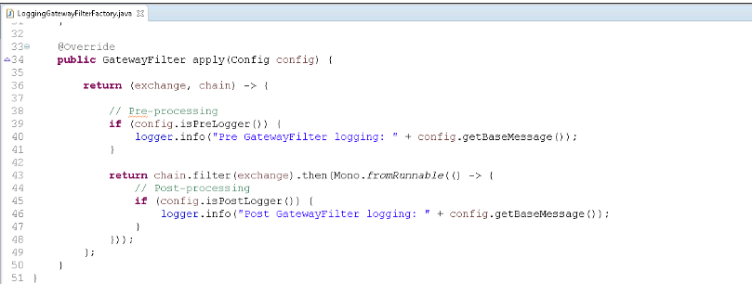

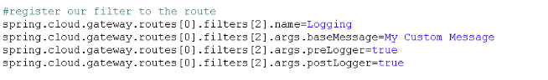

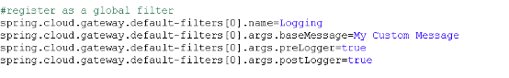

**-----------------------------------Day10----------------------------------------**

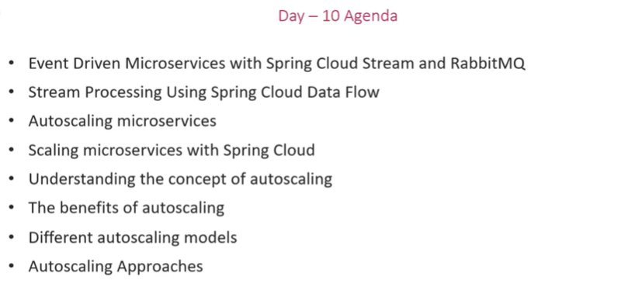

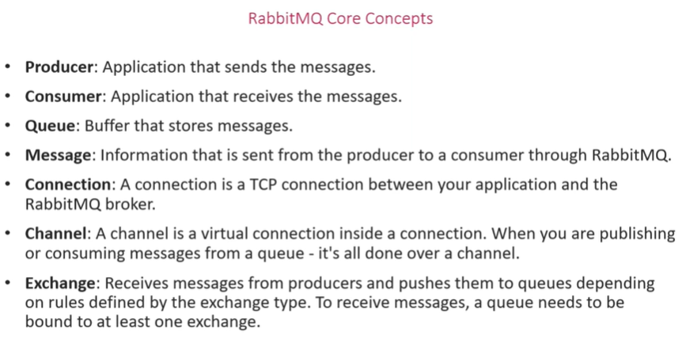

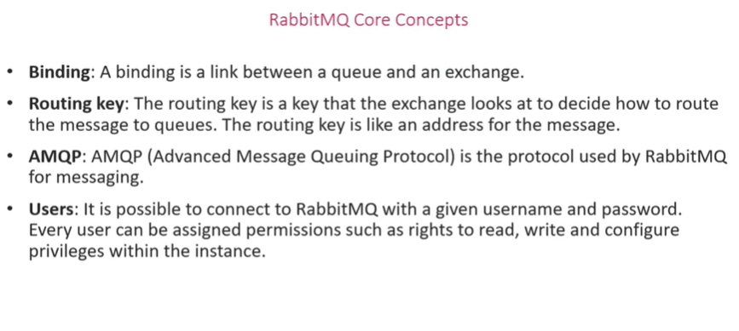

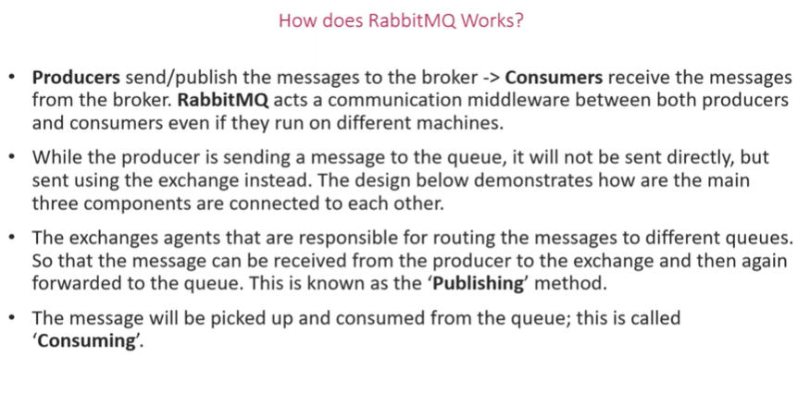

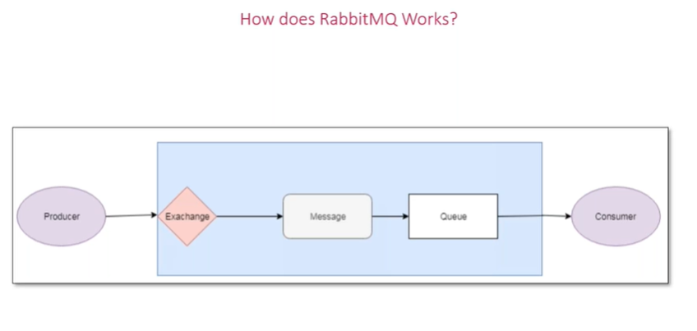

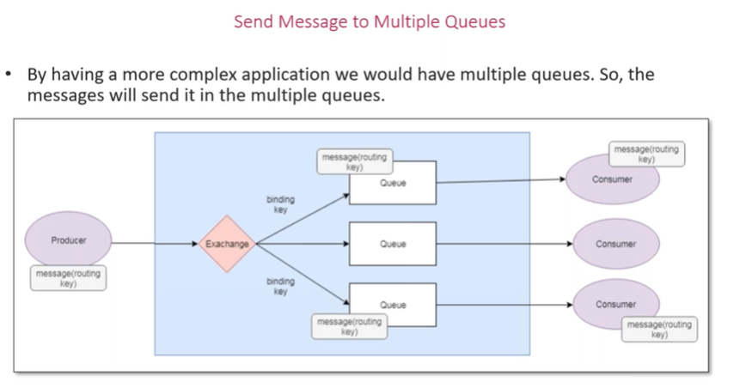

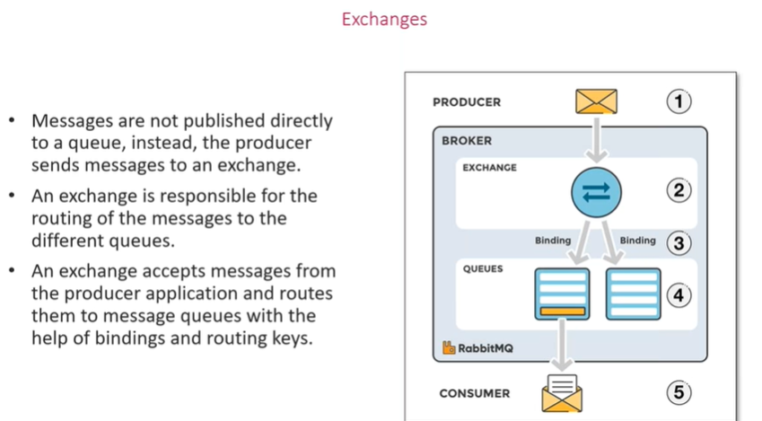

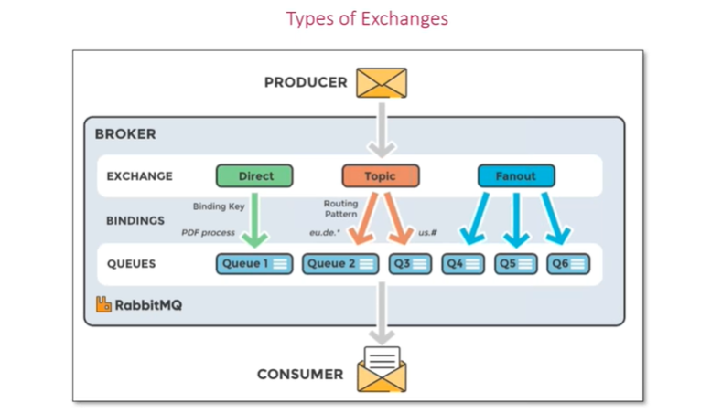

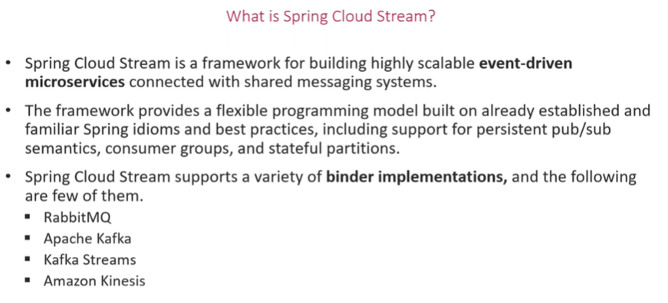

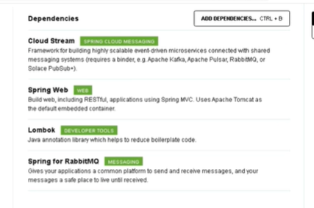

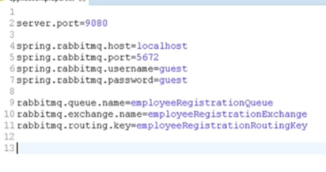

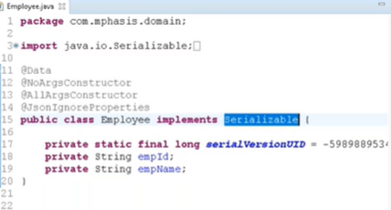

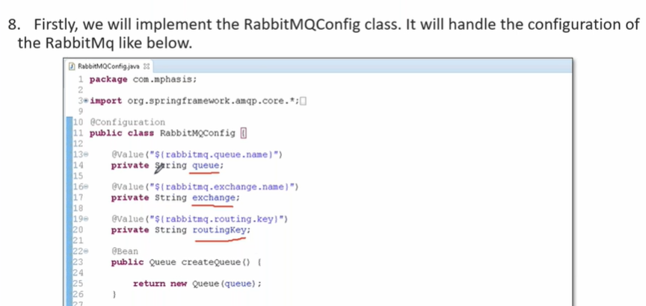

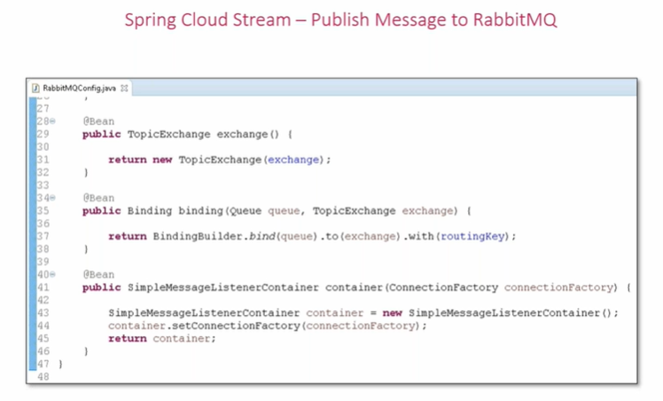

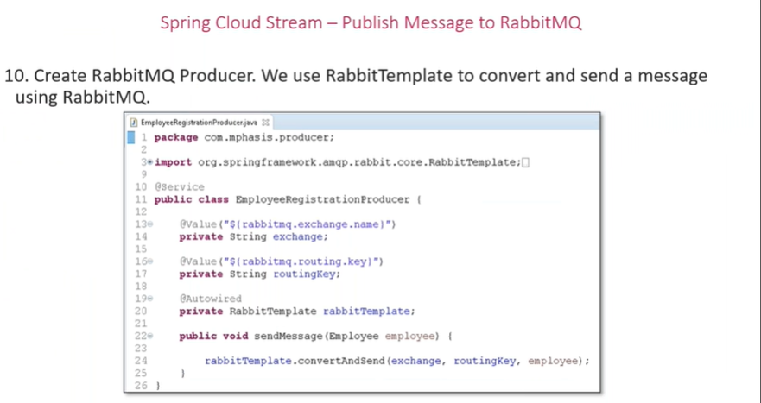

**Consumer**

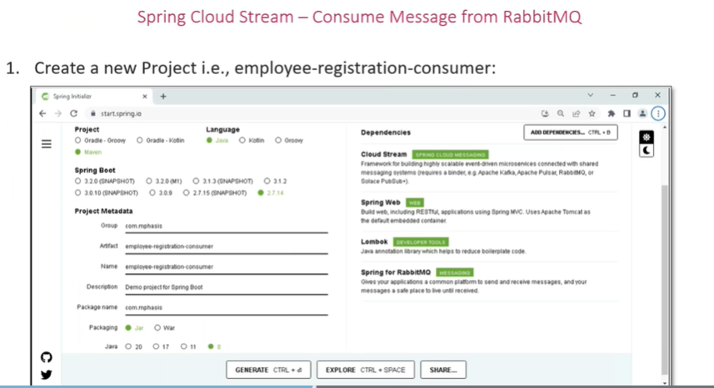

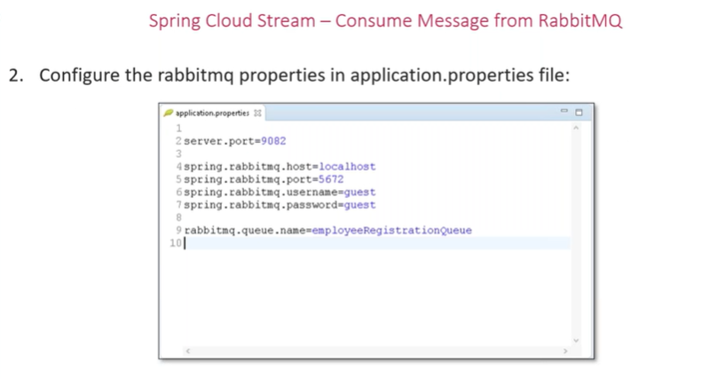



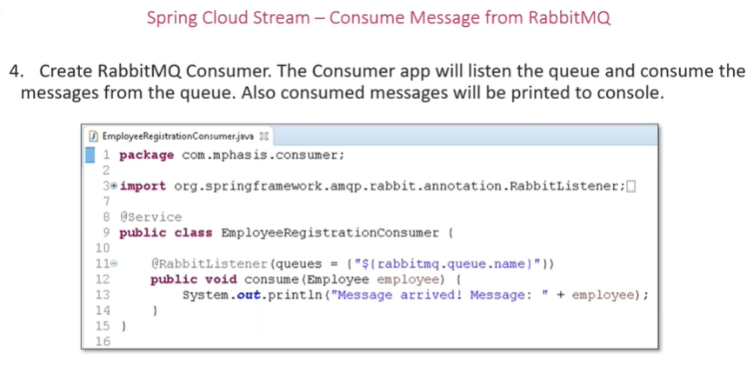

**Spring cloud data flow**

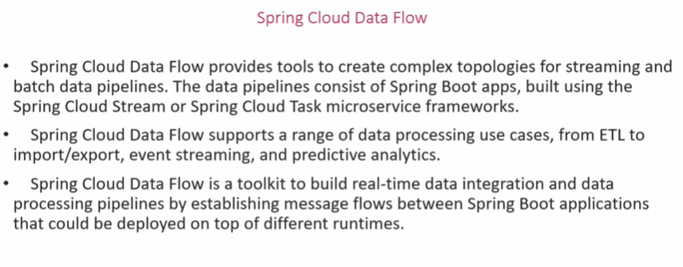

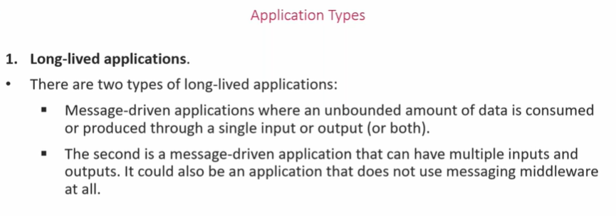

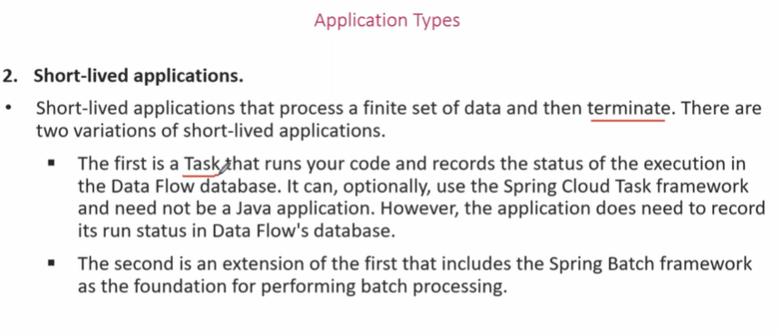

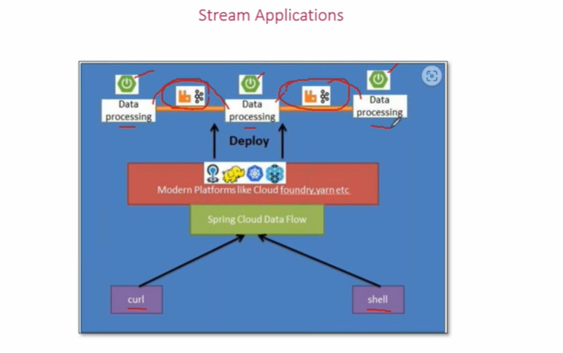

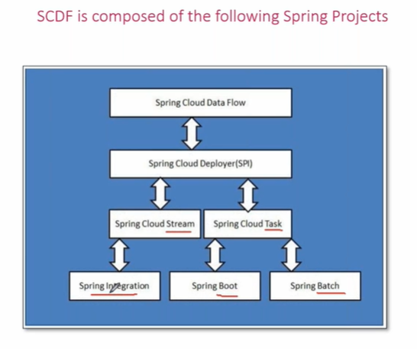

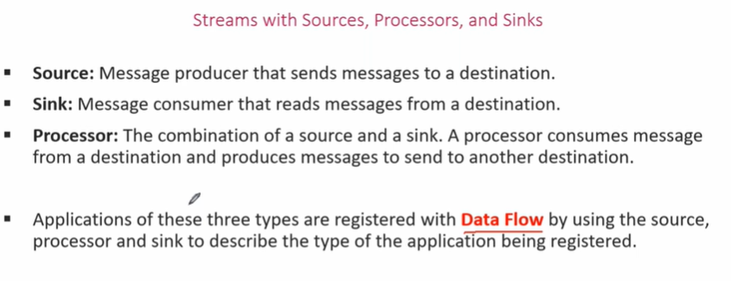

**Implementing stream processing using spring cloud data flow**

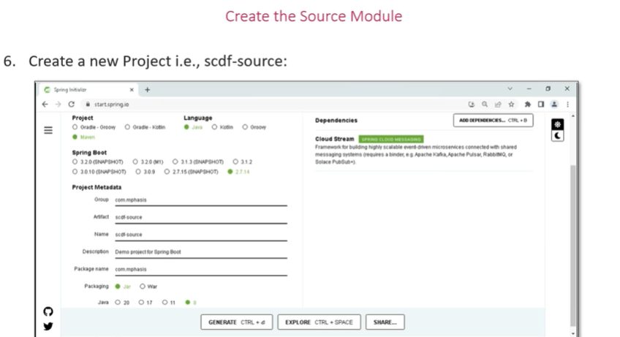

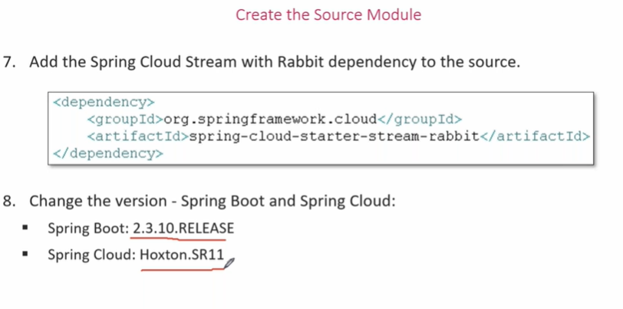

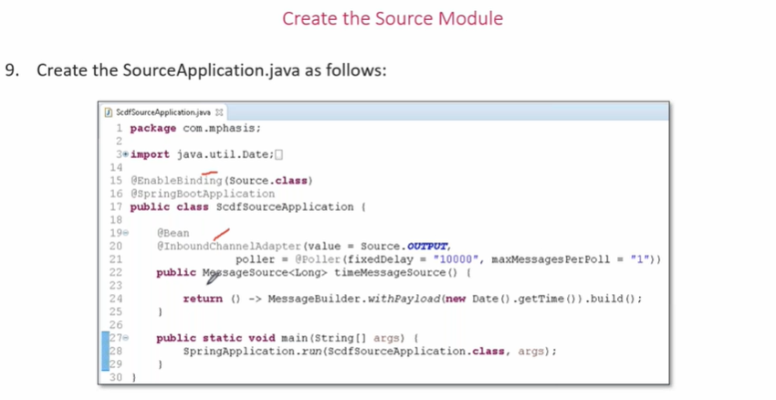

**Sdfc processor**

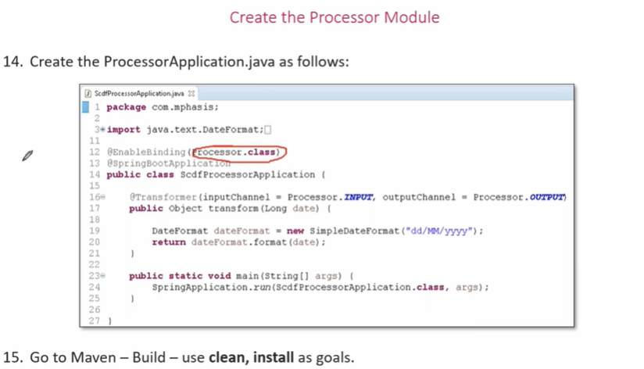

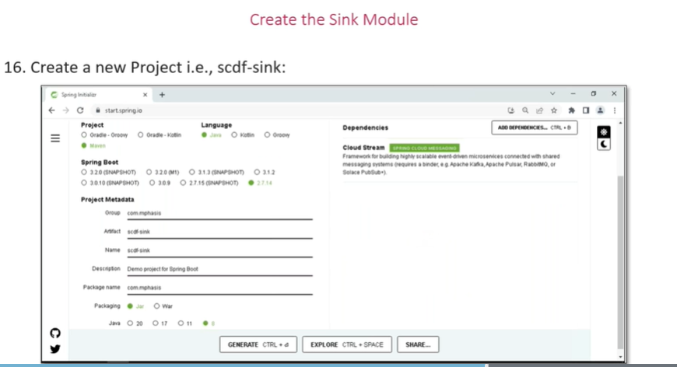

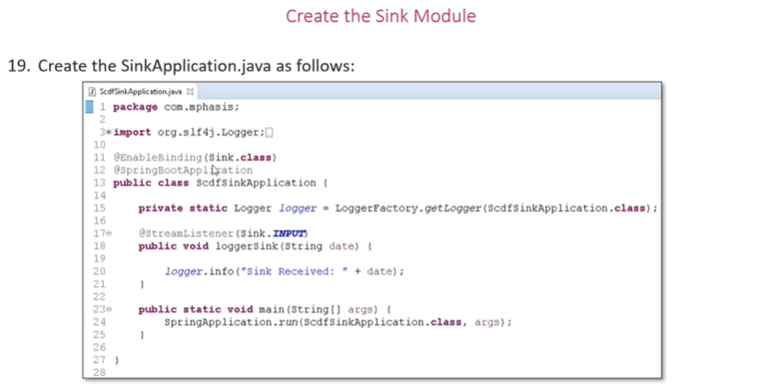

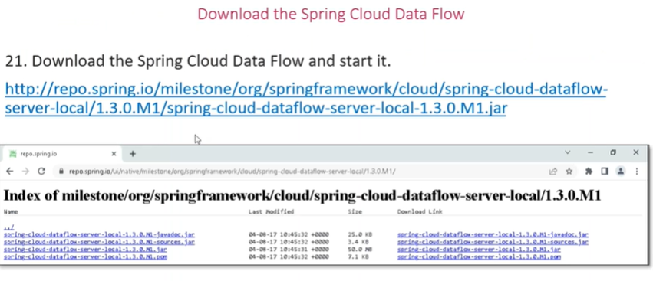

[**https://mvnrepository.com/artifact/org.springframework.cloud/spring-cloud-dataflow-server-local/1.3.0.RELEASE**](https://mvnrepository.com/artifact/org.springframework.cloud/spring-cloud-dataflow-server-local/1.3.0.RELEASE) 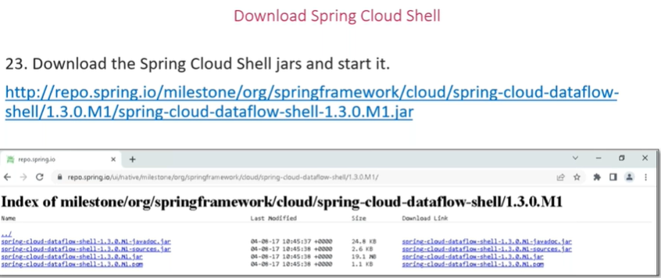

[**https://mvnrepository.com/artifact/org.springframework.cloud/spring-cloud-dataflow-shell/1.3.0.RELEASE**](https://mvnrepository.com/artifact/org.springframework.cloud/spring-cloud-dataflow-shell/1.3.0.RELEASE)

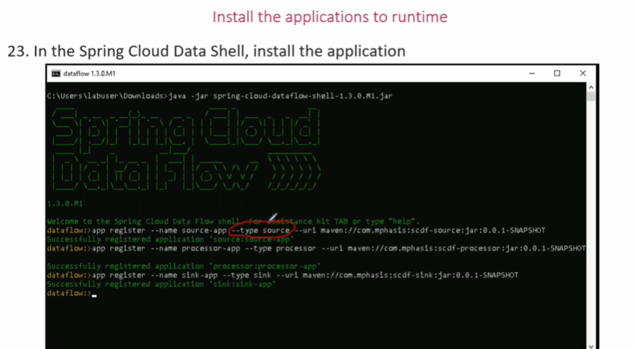

**app register --name source-file --type source --uri maven://com.example:scdf-source:jar:0.0.1-SNAPSHOT**

**app register --name sink-file --type sink --uri maven://com.example:scdf-sink:jar:0.0.1-SNAPSHOT**

**app register --name processor-file --type processor --uri maven://com.example:scdf-processor:jar:0.0.1-SNAPSHOT**

[**http://localhost:9393/dashboard/#/apps**](http://localhost:9393/dashboard/#/apps)

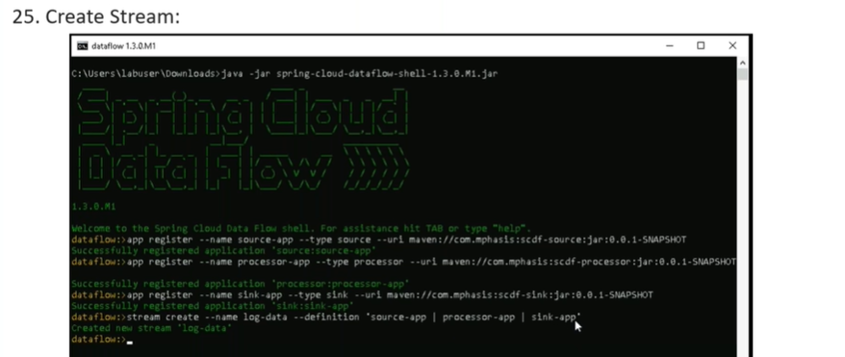

**stream create --name log-data --definition 'source-file | processor-file | sink-file'**

**stream deploy --name log-data**